UNITED STATES
SECURITIES AND EXCHANGE COMMISSION
WASHINGTON, D.C. 20549

FORM 6-K

REPORT OF FOREIGN PRIVATE ISSUER
PURSUANT TO RULE 13a-16 OR 15d-16 UNDER
THE SECURITIES EXCHANGE ACT OF 1934

For the month of September 2026

Commission File Number: 001-40460

KANZHUN LIMITED

21/F, GrandyVic Building,
Taiyanggong Middle Road
Chaoyang District, Beijing 100028
People’s Republic of China
(Address of principal executive offices)

Indicate by check mark whether the registrant files or will file annual reports under cover of Form 20-F or Form 40-F.

Form 20-F ☒ Form 40-F ☐

Exhibit Index

Exhibit No. |  | Description
99.1 |  | Next Day Disclosure Return, dated September 18, 2026

SIGNATURES

Pursuant to the requirements of the Securities Exchange Act of 1934, the registrant has duly caused this report to be signed on its behalf by the undersigned, thereunto duly authorized.

 | KANZHUN LIMITED
 | By | : | /s/ Peng Zhao
 | Name | : | Peng Zhao
 | Title | : | Director and Chief Executive Officer

Date: September 18, 2026

Exhibit 99.1
 | 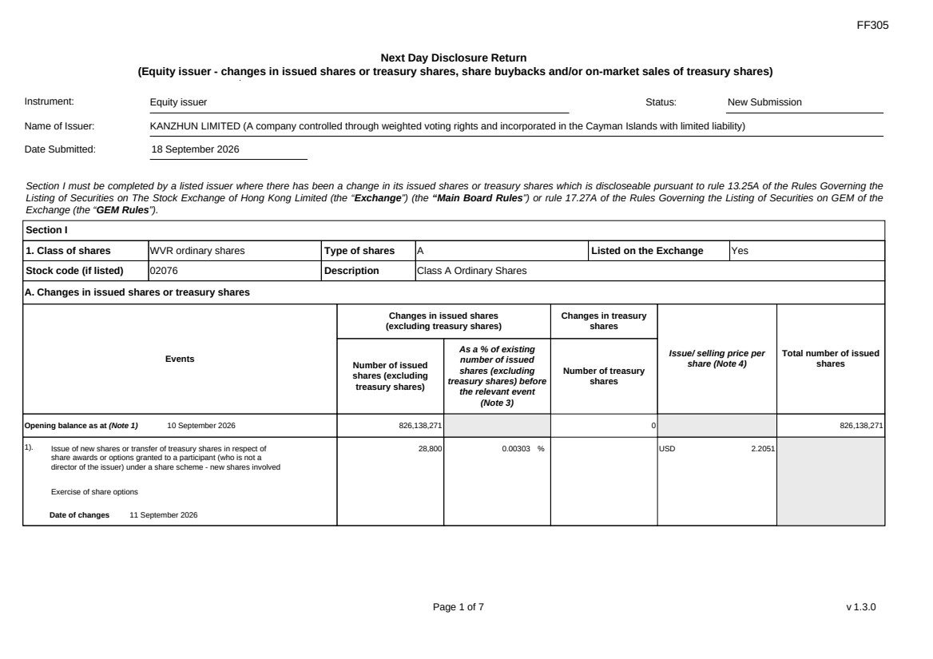 | FF305 Page 1 of 7 v 1.3.0 Next Day Disclosure Return (Equity issuer - changes in issued shares or treasury shares, share buybacks and/or on-market sales of treasury shares) Instrument: Equity issuer Status: New Submission Name of Issuer: KANZHUN LIMITED (A company controlled through weighted voting rights and incorporated in the Cayman Islands with limited liability) Date Submitted: 18 September 2026 Section I must be completed by a listed issuer where there has been a change in its issued shares or treasury shares which is discloseable pursuant to rule 13.25A of the Rules Governing the Listing of Securities on The Stock Exchange of Hong Kong Limited (the “Exchange”) (the “Main Board Rules”) or rule 17.27A of the Rules Governing the Listing of Securities on GEM of the Exchange (the “GEM Rules”). Section I 1. Class of shares WVR ordinary shares Type of shares A Listed on the Exchange Yes Stock code (if listed) 02076 Description Class A Ordinary Shares A. Changes in issued shares or treasury shares Events Changes in issued shares (excluding treasury shares) Number of issued shares (excluding treasury shares) As a % of existing number of issued shares (excluding treasury shares) before the relevant event (Note 3) Changes in treasury shares Number of treasury shares Issue/ selling price per share (Note 4) Total number of issued shares Opening balance as at (Note 1) 10 September 2026 826,138,271 0 826,138,271 1). Issue of new shares or transfer of treasury shares in respect of share awards or options granted to a participant (who is not a director of the issuer) under a share scheme - new shares involved Exercise of share options Date of changes 11 September 2026 28,800 0.00303 % USD 2.2051
 | 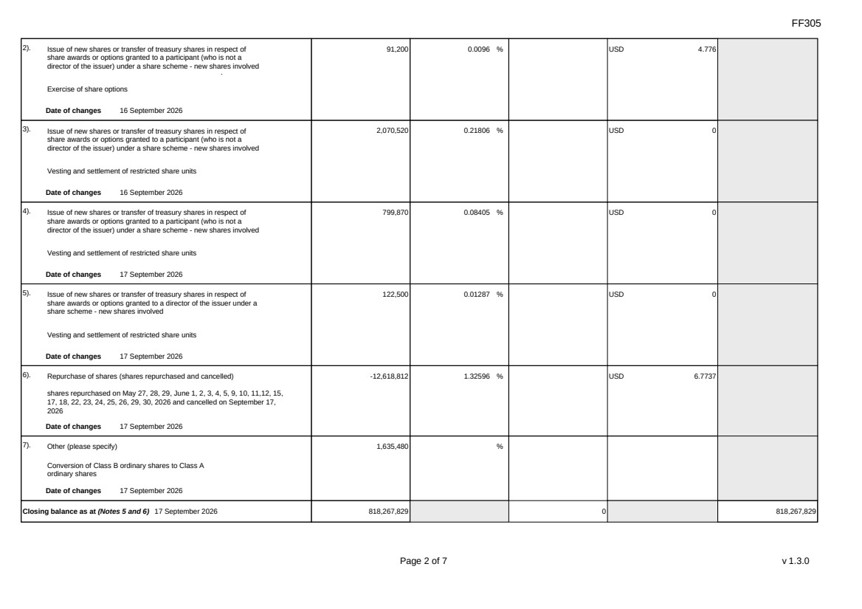 | FF305 Page 2 of 7 v 1.3.0 2). Issue of new shares or transfer of treasury shares in respect of share awards or options granted to a participant (who is not a director of the issuer) under a share scheme - new shares involved Exercise of share options Date of changes 16 September 2026 91,200 0.0096 % USD 4.776 3). Issue of new shares or transfer of treasury shares in respect of share awards or options granted to a participant (who is not a director of the issuer) under a share scheme - new shares involved Vesting and settlement of restricted share units Date of changes 16 September 2026 2,070,520 0.21806 % USD 0 4). Issue of new shares or transfer of treasury shares in respect of share awards or options granted to a participant (who is not a director of the issuer) under a share scheme - new shares involved Vesting and settlement of restricted share units Date of changes 17 September 2026 799,870 0.08405 % USD 0 5). Issue of new shares or transfer of treasury shares in respect of share awards or options granted to a director of the issuer under a share scheme - new shares involved Vesting and settlement of restricted share units Date of changes 17 September 2026 122,500 0.01287 % USD 0 6). Repurchase of shares (shares repurchased and cancelled) shares repurchased on May 27, 28, 29, June 1, 2, 3, 4, 5, 9, 10, 11,12, 15, 17, 18, 22, 23, 24, 25, 26, 29, 30, 2026 and cancelled on September 17, 2026 Date of changes 17 September 2026 -12,618,812 1.32596 % USD 6.7737 7). Other (please specify) Conversion of Class B ordinary shares to Class A ordinary shares Date of changes 17 September 2026 1,635,480 % Closing balance as at (Notes 5 and 6) 17 September 2026 818,267,829 0 818,267,829
 | 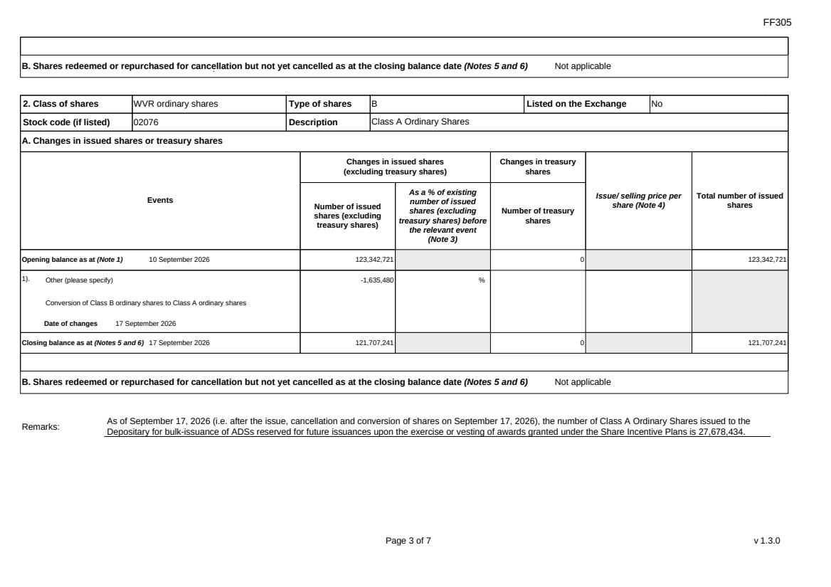 | FF305 Page 3 of 7 v 1.3.0 B. Shares redeemed or repurchased for cancellation but not yet cancelled as at the closing balance date (Notes 5 and 6) Not applicable 2. Class of shares WVR ordinary shares Type of shares B Listed on the Exchange No Stock code (if listed) 02076 Description Class A Ordinary Shares A. Changes in issued shares or treasury shares Events Changes in issued shares (excluding treasury shares) Number of issued shares (excluding treasury shares) As a % of existing number of issued shares (excluding treasury shares) before the relevant event (Note 3) Changes in treasury shares Number of treasury shares Issue/ selling price per share (Note 4) Total number of issued shares Opening balance as at (Note 1) 10 September 2026 123,342,721 0 123,342,721 1). Other (please specify) Conversion of Class B ordinary shares to Class A ordinary shares Date of changes 17 September 2026 -1,635,480 % Closing balance as at (Notes 5 and 6) 17 September 2026 121,707,241 0 121,707,241 B. Shares redeemed or repurchased for cancellation but not yet cancelled as at the closing balance date (Notes 5 and 6) Not applicable Remarks: As of September 17, 2026 (i.e. after the issue, cancellation and conversion of shares on September 17, 2026), the number of Class A Ordinary Shares issued to the Depositary for bulk-issuance of ADSs reserved for future issuances upon the exercise or vesting of awards granted under the Share Incentive Plans is 27,678,434.
 | 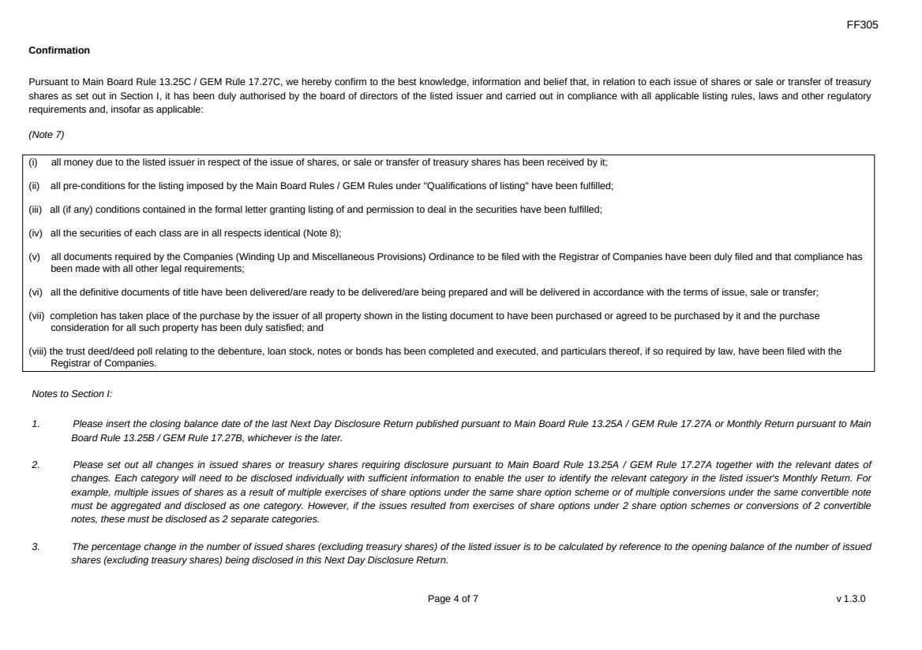 | FF305 Page 4 of 7 v 1.3.0 Confirmation Pursuant to Main Board Rule 13.25C / GEM Rule 17.27C, we hereby confirm to the best knowledge, information and belief that, in relation to each issue of shares or sale or transfer of treasury shares as set out in Section I, it has been duly authorised by the board of directors of the listed issuer and carried out in compliance with all applicable listing rules, laws and other regulatory requirements and, insofar as applicable: (Note 7) (i) all money due to the listed issuer in respect of the issue of shares, or sale or transfer of treasury shares has been received by it; (ii) all pre-conditions for the listing imposed by the Main Board Rules / GEM Rules under "Qualifications of listing" have been fulfilled; (iii) all (if any) conditions contained in the formal letter granting listing of and permission to deal in the securities have been fulfilled; (iv) all the securities of each class are in all respects identical (Note 8); (v) all documents required by the Companies (Winding Up and Miscellaneous Provisions) Ordinance to be filed with the Registrar of Companies have been duly filed and that compliance has been made with all other legal requirements; (vi) all the definitive documents of title have been delivered/are ready to be delivered/are being prepared and will be delivered in accordance with the terms of issue, sale or transfer; (vii) completion has taken place of the purchase by the issuer of all property shown in the listing document to have been purchased or agreed to be purchased by it and the purchase consideration for all such property has been duly satisfied; and (viii) the trust deed/deed poll relating to the debenture, loan stock, notes or bonds has been completed and executed, and particulars thereof, if so required by law, have been filed with the Registrar of Companies. Notes to Section I: 1. Please insert the closing balance date of the last Next Day Disclosure Return published pursuant to Main Board Rule 13.25A / GEM Rule 17.27A or Monthly Return pursuant to Main Board Rule 13.25B / GEM Rule 17.27B, whichever is the later. 2. Please set out all changes in issued shares or treasury shares requiring disclosure pursuant to Main Board Rule 13.25A / GEM Rule 17.27A together with the relevant dates of changes. Each category will need to be disclosed individually with sufficient information to enable the user to identify the relevant category in the listed issuer's Monthly Return. For example, multiple issues of shares as a result of multiple exercises of share options under the same share option scheme or of multiple conversions under the same convertible note must be aggregated and disclosed as one category. However, if the issues resulted from exercises of share options under 2 share option schemes or conversions of 2 convertible notes, these must be disclosed as 2 separate categories. 3. The percentage change in the number of issued shares (excluding treasury shares) of the listed issuer is to be calculated by reference to the opening balance of the number of issued shares (excluding treasury shares) being disclosed in this Next Day Disclosure Return.
 | 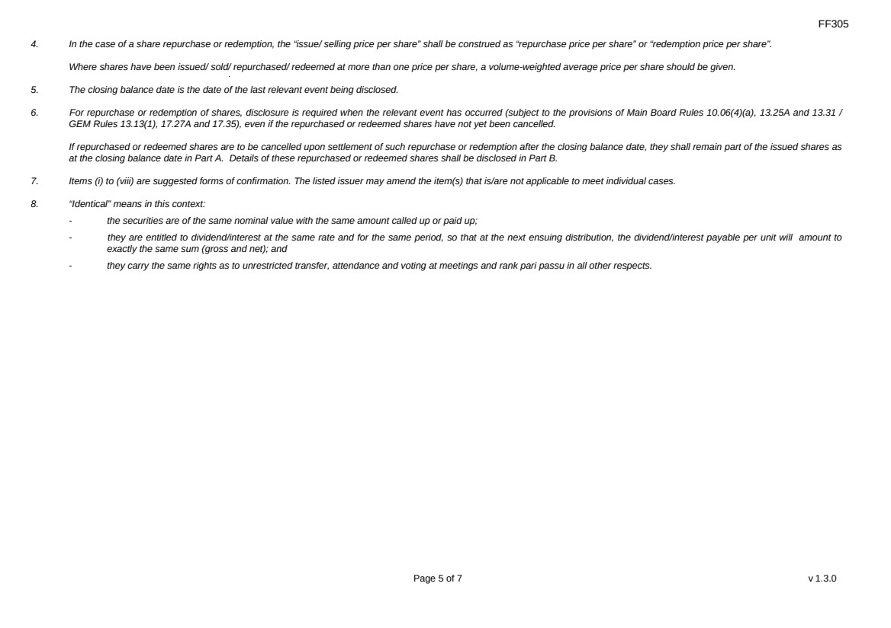 | FF305 Page 5 of 7 v 1.3.0 4. In the case of a share repurchase or redemption, the “issue/ selling price per share” shall be construed as “repurchase price per share” or “redemption price per share”. Where shares have been issued/ sold/ repurchased/ redeemed at more than one price per share, a volume-weighted average price per share should be given. 5. The closing balance date is the date of the last relevant event being disclosed. 6. For repurchase or redemption of shares, disclosure is required when the relevant event has occurred (subject to the provisions of Main Board Rules 10.06(4)(a), 13.25A and 13.31 / GEM Rules 13.13(1), 17.27A and 17.35), even if the repurchased or redeemed shares have not yet been cancelled. If repurchased or redeemed shares are to be cancelled upon settlement of such repurchase or redemption after the closing balance date, they shall remain part of the issued shares as at the closing balance date in Part A. Details of these repurchased or redeemed shares shall be disclosed in Part B. 7. Items (i) to (viii) are suggested forms of confirmation. The listed issuer may amend the item(s) that is/are not applicable to meet individual cases. 8. “Identical” means in this context: - the securities are of the same nominal value with the same amount called up or paid up; - they are entitled to dividend/interest at the same rate and for the same period, so that at the next ensuing distribution, the dividend/interest payable per unit will amount to exactly the same sum (gross and net); and - they carry the same rights as to unrestricted transfer, attendance and voting at meetings and rank pari passu in all other respects.
 | 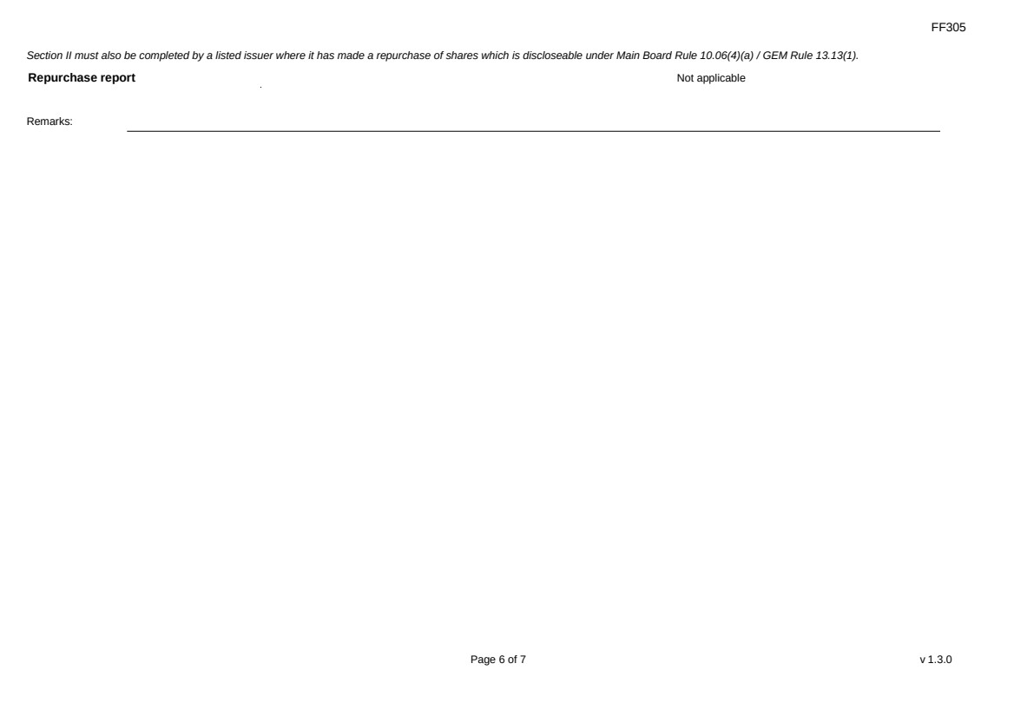 | FF305 Page 6 of 7 v 1.3.0 Section II must also be completed by a listed issuer where it has made a repurchase of shares which is discloseable under Main Board Rule 10.06(4)(a) / GEM Rule 13.13(1). Repurchase report Not applicable Remarks:
 | 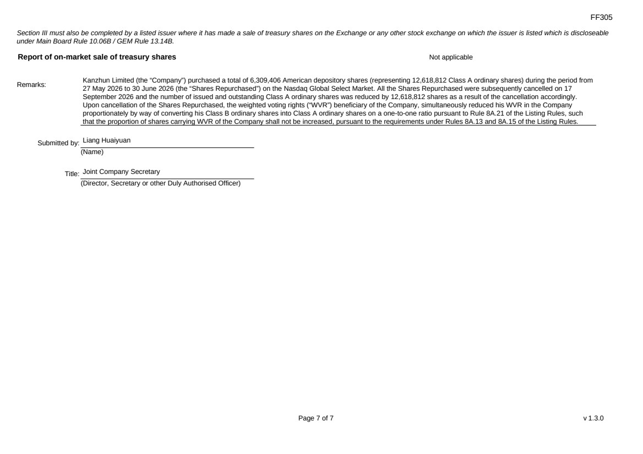 | FF305 Page 7 of 7 v 1.3.0 Section III must also be completed by a listed issuer where it has made a sale of treasury shares on the Exchange or any other stock exchange on which the issuer is listed which is discloseable under Main Board Rule 10.06B / GEM Rule 13.14B. Report of on-market sale of treasury shares Not applicable Remarks: Kanzhun Limited (the “Company”) purchased a total of 6,309,406 American depository shares (representing 12,618,812 Class A ordinary shares) during the period from 27 May 2026 to 30 June 2026 (the “Shares Repurchased”) on the Nasdaq Global Select Market. All the Shares Repurchased were subsequently cancelled on 17 September 2026 and the number of issued and outstanding Class A ordinary shares was reduced by 12,618,812 shares as a result of the cancellation accordingly. Upon cancellation of the Shares Repurchased, the weighted voting rights (“WVR”) beneficiary of the Company, simultaneously reduced his WVR in the Company proportionately by way of converting his Class B ordinary shares into Class A ordinary shares on a one-to-one ratio pursuant to Rule 8A.21 of the Listing Rules, such that the proportion of shares carrying WVR of the Company shall not be increased, pursuant to the requirements under Rules 8A.13 and 8A.15 of the Listing Rules. Submitted by: Liang Huaiyuan (Name) Title: Joint Company Secretary (Director, Secretary or other Duly Authorised Officer)

