UNITED STATES
SECURITIES AND EXCHANGE COMMISSION
WASHINGTON, D.C. 20549

FORM 6-K

REPORT OF FOREIGN PRIVATE ISSUER
PURSUANT TO RULE 13a-16 OR 15d-16 UNDER
THE SECURITIES EXCHANGE ACT OF 1934

For the month of July 2026

Commission File Number: 001-40460

KANZHUN LIMITED

21/F, GrandyVic Building,
Taiyanggong Middle Road
Chaoyang District, Beijing 100028
People’s Republic of China
(Address of principal executive offices)

Indicate by check mark whether the registrant files or will file annual reports under cover of Form 20-F or Form 40-F.

Form 20-F ☒ Form 40-F ☐

Exhibit Index

Exhibit No. |  | Description
99.1 |  | Monthly Return for Equity Issuer and Hong Kong Depositary Receipts listed under Chapter 19B of the Exchange Listing Rules on Movements in Securities

SIGNATURES

Pursuant to the requirements of the Securities Exchange Act of 1934, the registrant has duly caused this report to be signed on its behalf by the undersigned, thereunto duly authorized.

 | KANZHUN LIMITED
 | By | : | /s/ Peng Zhao
 | Name | : | Peng Zhao
 | Title | : | Director and Chief Executive Officer

Date: July 7, 2026

Exhibit 99.1
 | 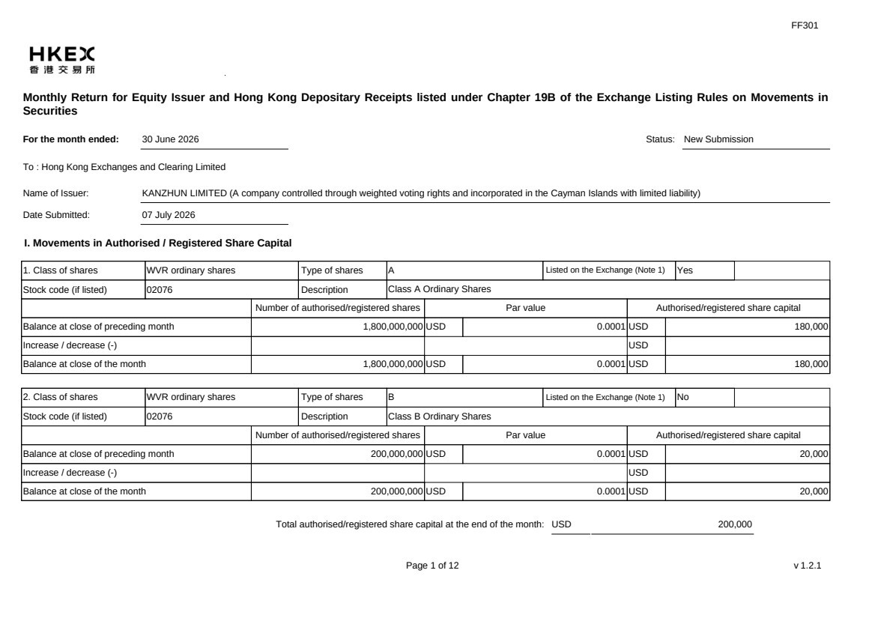 | FF301 Page 1 of 12 v 1.2.1 Monthly Return for Equity Issuer and Hong Kong Depositary Receipts listed under Chapter 19B of the Exchange Listing Rules on Movements in Securities For the month ended: 30 June 2026 Status: New Submission To : Hong Kong Exchanges and Clearing Limited Name of Issuer: KANZHUN LIMITED (A company controlled through weighted voting rights and incorporated in the Cayman Islands with limited liability) Date Submitted: 07 July 2026 I. Movements in Authorised / Registered Share Capital 1. Class of shares WVR ordinary shares Type of shares A Listed on the Exchange (Note 1) Yes Stock code (if listed) 02076 Description Class A Ordinary Shares Number of authorised/registered shares Par value Authorised/registered share capital Balance at close of preceding month 1,800,000,000 USD 0.0001 USD 180,000 Increase / decrease (-) USD Balance at close of the month 1,800,000,000 USD 0.0001 USD 180,000 2. Class of shares WVR ordinary shares Type of shares B Listed on the Exchange (Note 1) No Stock code (if listed) 02076 Description Class B Ordinary Shares Number of authorised/registered shares Par value Authorised/registered share capital Balance at close of preceding month 200,000,000 USD 0.0001 USD 20,000 Increase / decrease (-) USD Balance at close of the month 200,000,000 USD 0.0001 USD 20,000 Total authorised/registered share capital at the end of the month: USD 200,000
 | 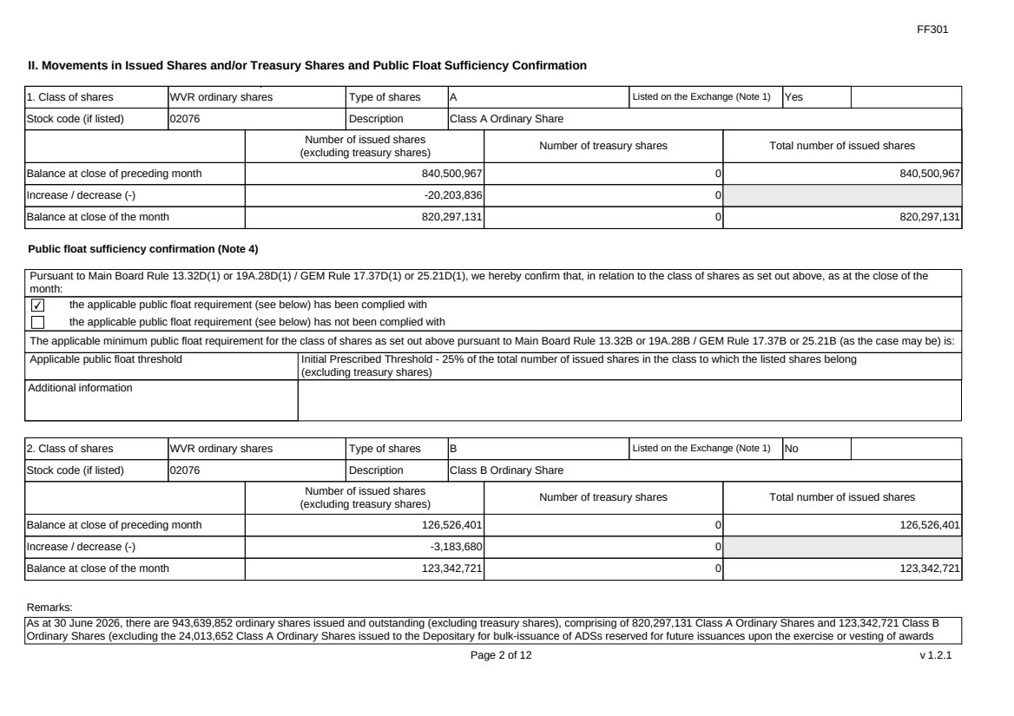 | FF301 Page 2 of 12 v 1.2.1 II. Movements in Issued Shares and/or Treasury Shares and Public Float Sufficiency Confirmation 1. Class of shares WVR ordinary shares Type of shares A Listed on the Exchange (Note 1) Yes Stock code (if listed) 02076 Description Class A Ordinary Share Number of issued shares (excluding treasury shares) Number of treasury shares Total number of issued shares Balance at close of preceding month 840,500,967 0 840,500,967 Increase / decrease (-) -20,203,836 0 Balance at close of the month 820,297,131 0 820,297,131 Public float sufficiency confirmation (Note 4) Pursuant to Main Board Rule 13.32D(1) or 19A.28D(1) / GEM Rule 17.37D(1) or 25.21D(1), we hereby confirm that, in relation to the class of shares as set out above, as at the close of the month: ✔ the applicable public float requirement (see below) has been complied with the applicable public float requirement (see below) has not been complied with The applicable minimum public float requirement for the class of shares as set out above pursuant to Main Board Rule 13.32B or 19A.28B / GEM Rule 17.37B or 25.21B (as the case may be) is: Applicable public float threshold Initial Prescribed Threshold - 25% of the total number of issued shares in the class to which the listed shares belong (excluding treasury shares) Additional information 2. Class of shares WVR ordinary shares Type of shares B Listed on the Exchange (Note 1) No Stock code (if listed) 02076 Description Class B Ordinary Share Number of issued shares (excluding treasury shares) Number of treasury shares Total number of issued shares Balance at close of preceding month 126,526,401 0 126,526,401 Increase / decrease (-) -3,183,680 0 Balance at close of the month 123,342,721 0 123,342,721 Remarks: As at 30 June 2026, there are 943,639,852 ordinary shares issued and outstanding (excluding treasury shares), comprising of 820,297,131 Class A Ordinary Shares and 123,342,721 Class B Ordinary Shares (excluding the 24,013,652 Class A Ordinary Shares issued to the Depositary for bulk-issuance of ADSs reserved for future issuances upon the exercise or vesting of awards
 | 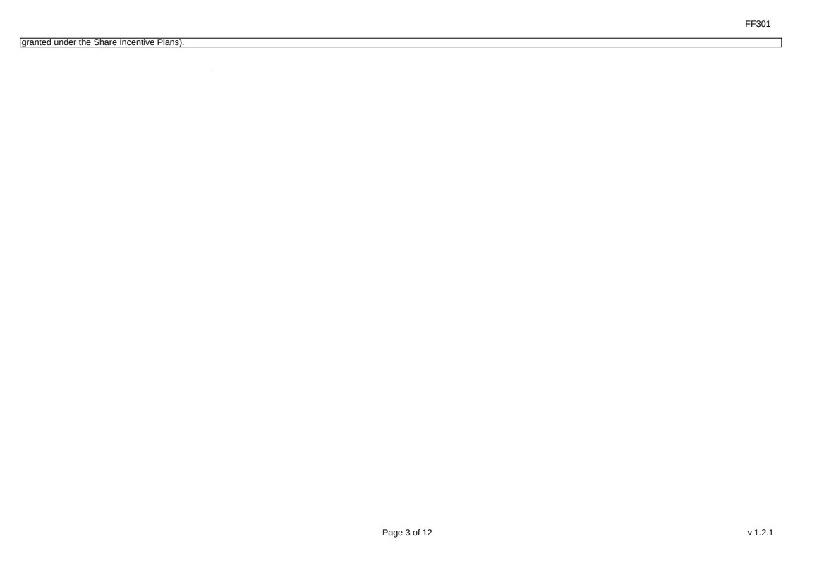 | FF301 Page 3 of 12 v 1.2.1 granted under the Share Incentive Plans).
 | 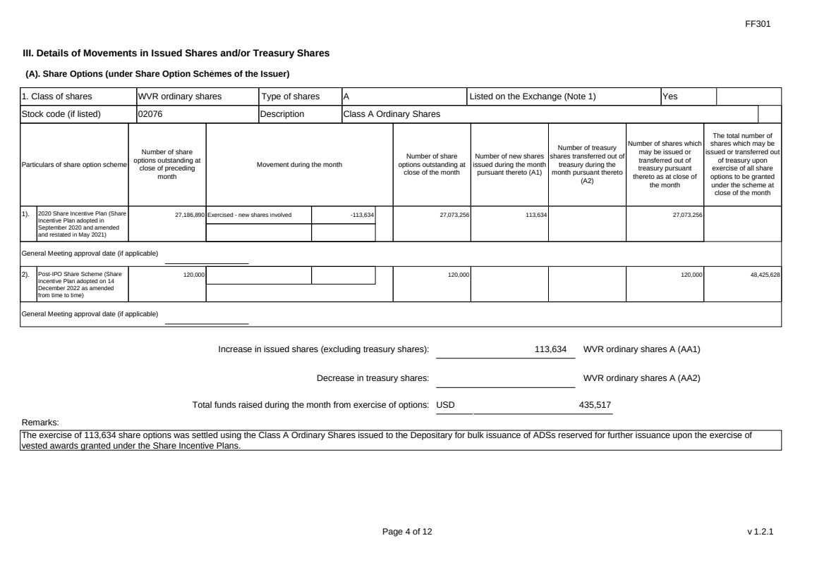 | FF301 Page 4 of 12 v 1.2.1 III. Details of Movements in Issued Shares and/or Treasury Shares (A). Share Options (under Share Option Schemes of the Issuer) 1. Class of shares WVR ordinary shares Type of shares A Listed on the Exchange (Note 1) Yes Stock code (if listed) 02076 Description Class A Ordinary Shares Particulars of share option scheme Number of share options outstanding at close of preceding month Movement during the month Number of share options outstanding at close of the month Number of new shares issued during the month pursuant thereto (A1) Number of treasury shares transferred out of treasury during the month pursuant thereto (A2) Number of shares which may be issued or transferred out of treasury pursuant thereto as at close of the month The total number of shares which may be issued or transferred out of treasury upon exercise of all share options to be granted under the scheme at close of the month 1). 2020 Share Incentive Plan (Share Incentive Plan adopted in September 2020 and amended and restated in May 2021) 27,186,890 Exercised - new shares involved -113,634 27,073,256 113,634 27,073,256 General Meeting approval date (if applicable) 2). Post-IPO Share Scheme (Share Incentive Plan adopted on 14 December 2022 as amended from time to time) 120,000 120,000 120,000 48,425,628 General Meeting approval date (if applicable) Increase in issued shares (excluding treasury shares): 113,634 WVR ordinary shares A (AA1) Decrease in treasury shares: WVR ordinary shares A (AA2) Total funds raised during the month from exercise of options: USD 435,517 Remarks: The exercise of 113,634 share options was settled using the Class A Ordinary Shares issued to the Depositary for bulk issuance of ADSs reserved for further issuance upon the exercise of vested awards granted under the Share Incentive Plans.
 |  | FF301 Page 5 of 12 v 1.2.1 (B). Warrants to Issue Shares of the Issuer Not applicable
 | 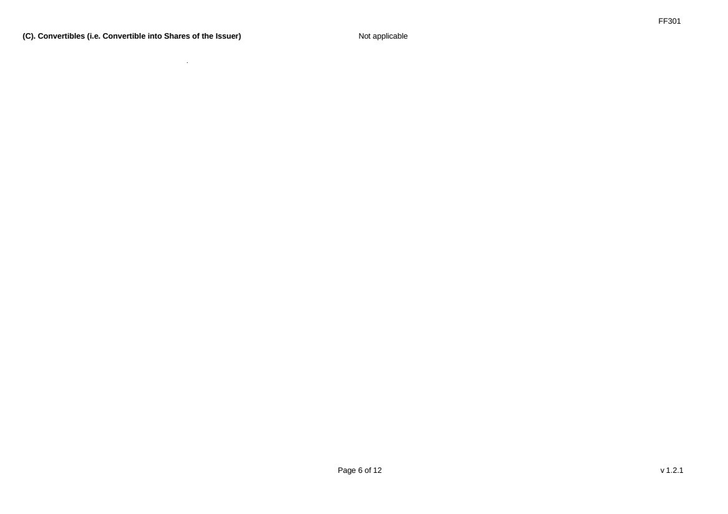 | FF301 Page 6 of 12 v 1.2.1 (C). Convertibles (i.e. Convertible into Shares of the Issuer) Not applicable
 | 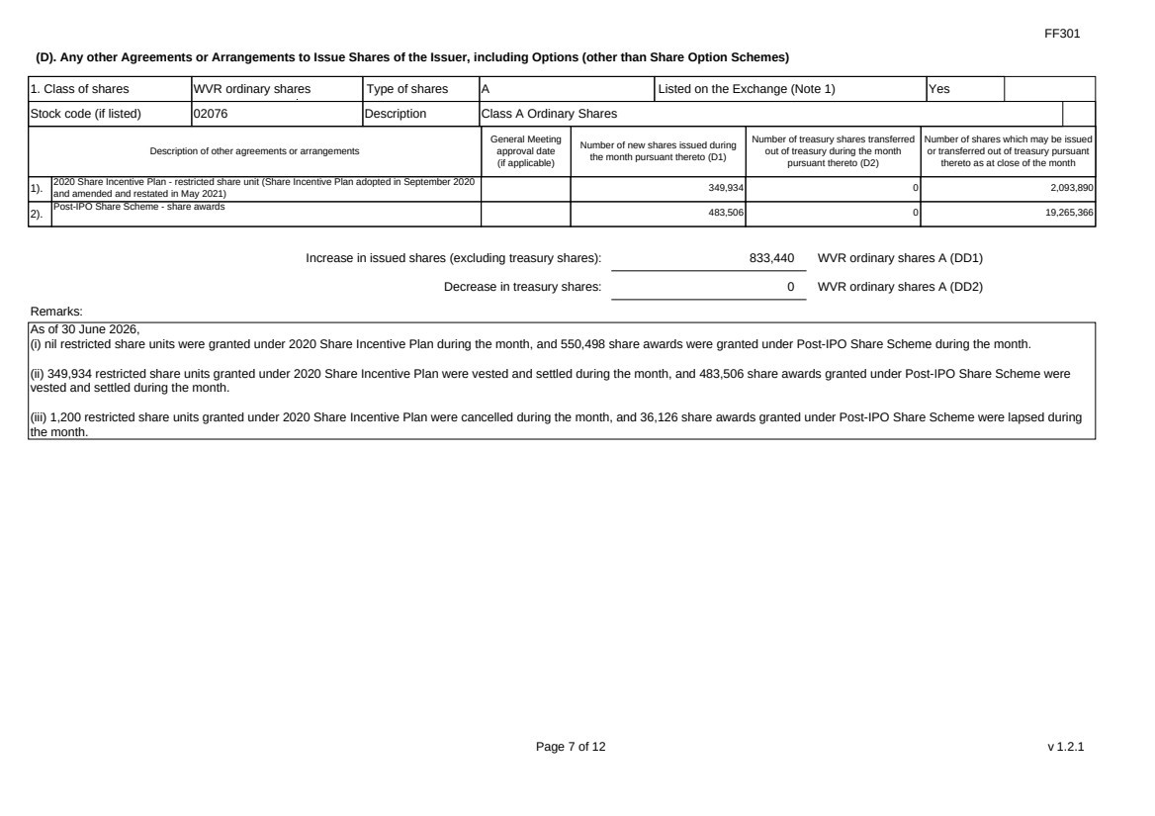 | FF301 Page 7 of 12 v 1.2.1 (D). Any other Agreements or Arrangements to Issue Shares of the Issuer, including Options (other than Share Option Schemes) 1. Class of shares WVR ordinary shares Type of shares A Listed on the Exchange (Note 1) Yes Stock code (if listed) 02076 Description Class A Ordinary Shares Description of other agreements or arrangements General Meeting approval date (if applicable) Number of new shares issued during the month pursuant thereto (D1) Number of treasury shares transferred out of treasury during the month pursuant thereto (D2) Number of shares which may be issued or transferred out of treasury pursuant thereto as at close of the month 1). 2020 Share Incentive Plan - restricted share unit (Share Incentive Plan adopted in September 2020 and amended and restated in May 2021) 349,934 0 2,093,890 2). Post-IPO Share Scheme - share awards 483,506 0 19,265,366 Increase in issued shares (excluding treasury shares): 833,440 WVR ordinary shares A (DD1) Decrease in treasury shares: 0 WVR ordinary shares A (DD2) Remarks: As of 30 June 2026, (i) nil restricted share units were granted under 2020 Share Incentive Plan during the month, and 550,498 share awards were granted under Post-IPO Share Scheme during the month. (ii) 349,934 restricted share units granted under 2020 Share Incentive Plan were vested and settled during the month, and 483,506 share awards granted under Post-IPO Share Scheme were vested and settled during the month. (iii) 1,200 restricted share units granted under 2020 Share Incentive Plan were cancelled during the month, and 36,126 share awards granted under Post-IPO Share Scheme were lapsed during the month.
 | 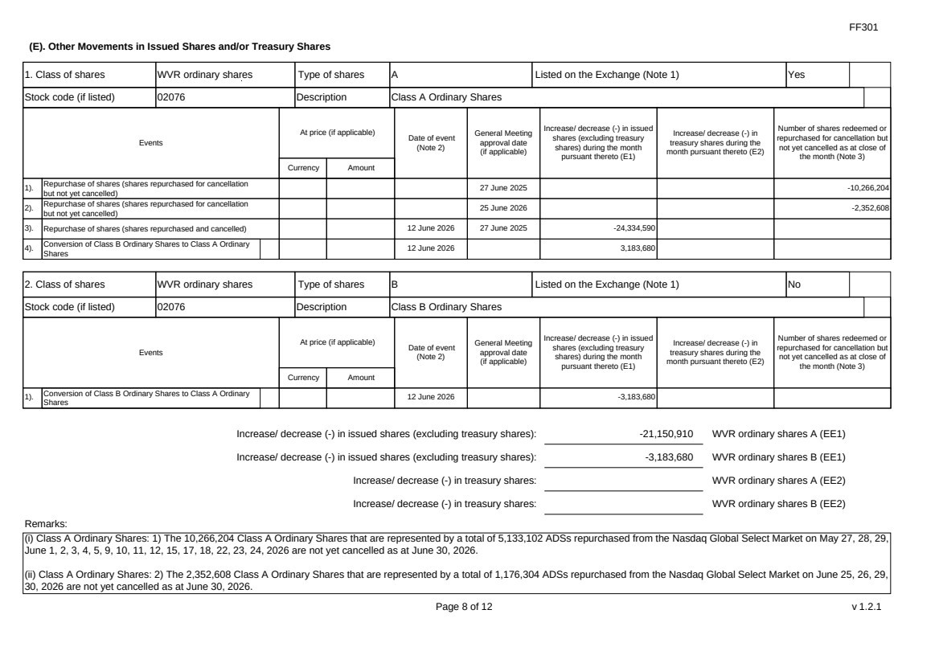 | FF301 Page 8 of 12 v 1.2.1 (E). Other Movements in Issued Shares and/or Treasury Shares 1. Class of shares WVR ordinary shares Type of shares A Listed on the Exchange (Note 1) Yes Stock code (if listed) 02076 Description Class A Ordinary Shares Events At price (if applicable) Currency Amount Date of event (Note 2) General Meeting approval date (if applicable) Increase/ decrease (-) in issued shares (excluding treasury shares) during the month pursuant thereto (E1) Increase/ decrease (-) in treasury shares during the month pursuant thereto (E2) Number of shares redeemed or repurchased for cancellation but not yet cancelled as at close of the month (Note 3) 1). Repurchase of shares (shares repurchased for cancellation but not yet cancelled) 27 June 2025 -10,266,204 2). Repurchase of shares (shares repurchased for cancellation but not yet cancelled) 25 June 2026 -2,352,608 3). Repurchase of shares (shares repurchased and cancelled) 12 June 2026 27 June 2025 -24,334,590 4). Conversion of Class B Ordinary Shares to Class A Ordinary Shares 12 June 2026 3,183,680 2. Class of shares WVR ordinary shares Type of shares B Listed on the Exchange (Note 1) No Stock code (if listed) 02076 Description Class B Ordinary Shares Events At price (if applicable) Currency Amount Date of event (Note 2) General Meeting approval date (if applicable) Increase/ decrease (-) in issued shares (excluding treasury shares) during the month pursuant thereto (E1) Increase/ decrease (-) in treasury shares during the month pursuant thereto (E2) Number of shares redeemed or repurchased for cancellation but not yet cancelled as at close of the month (Note 3) 1). Conversion of Class B Ordinary Shares to Class A Ordinary Shares 12 June 2026 -3,183,680 Increase/ decrease (-) in issued shares (excluding treasury shares): -21,150,910 WVR ordinary shares A (EE1) Increase/ decrease (-) in issued shares (excluding treasury shares): -3,183,680 WVR ordinary shares B (EE1) Increase/ decrease (-) in treasury shares: WVR ordinary shares A (EE2) Increase/ decrease (-) in treasury shares: WVR ordinary shares B (EE2) Remarks: (i) Class A Ordinary Shares: 1) The 10,266,204 Class A Ordinary Shares that are represented by a total of 5,133,102 ADSs repurchased from the Nasdaq Global Select Market on May 27, 28, 29, June 1, 2, 3, 4, 5, 9, 10, 11, 12, 15, 17, 18, 22, 23, 24, 2026 are not yet cancelled as at June 30, 2026. (ii) Class A Ordinary Shares: 2) The 2,352,608 Class A Ordinary Shares that are represented by a total of 1,176,304 ADSs repurchased from the Nasdaq Global Select Market on June 25, 26, 29, 30, 2026 are not yet cancelled as at June 30, 2026.
 | 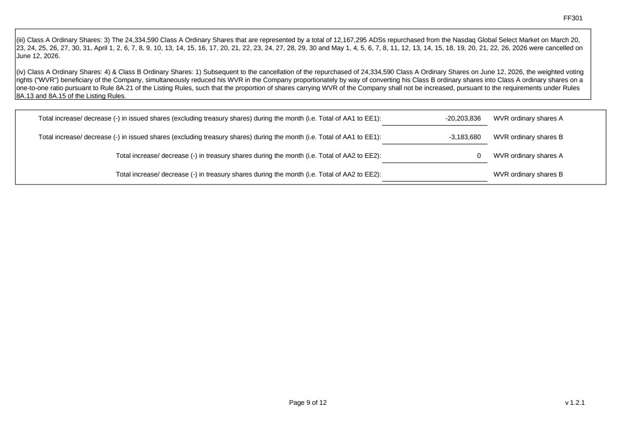 | FF301 Page 9 of 12 v 1.2.1 (iii) Class A Ordinary Shares: 3) The 24,334,590 Class A Ordinary Shares that are represented by a total of 12,167,295 ADSs repurchased from the Nasdaq Global Select Market on March 20, 23, 24, 25, 26, 27, 30, 31, April 1, 2, 6, 7, 8, 9, 10, 13, 14, 15, 16, 17, 20, 21, 22, 23, 24, 27, 28, 29, 30 and May 1, 4, 5, 6, 7, 8, 11, 12, 13, 14, 15, 18, 19, 20, 21, 22, 26, 2026 were cancelled on June 12, 2026. (iv) Class A Ordinary Shares: 4) & Class B Ordinary Shares: 1) Subsequent to the cancellation of the repurchased of 24,334,590 Class A Ordinary Shares on June 12, 2026, the weighted voting rights (“WVR”) beneficiary of the Company, simultaneously reduced his WVR in the Company proportionately by way of converting his Class B ordinary shares into Class A ordinary shares on a one-to-one ratio pursuant to Rule 8A.21 of the Listing Rules, such that the proportion of shares carrying WVR of the Company shall not be increased, pursuant to the requirements under Rules 8A.13 and 8A.15 of the Listing Rules. Total increase/ decrease (-) in issued shares (excluding treasury shares) during the month (i.e. Total of AA1 to EE1): -20,203,836 WVR ordinary shares A Total increase/ decrease (-) in issued shares (excluding treasury shares) during the month (i.e. Total of AA1 to EE1): -3,183,680 WVR ordinary shares B Total increase/ decrease (-) in treasury shares during the month (i.e. Total of AA2 to EE2): 0 WVR ordinary shares A Total increase/ decrease (-) in treasury shares during the month (i.e. Total of AA2 to EE2): WVR ordinary shares B
 | 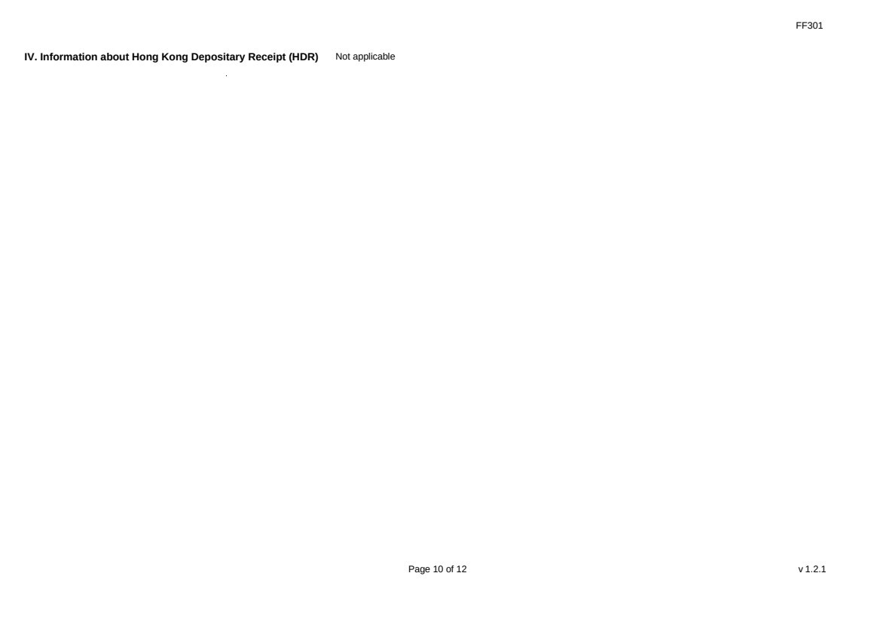 | FF301 Page 10 of 12 v 1.2.1 IV. Information about Hong Kong Depositary Receipt (HDR) Not applicable
 | 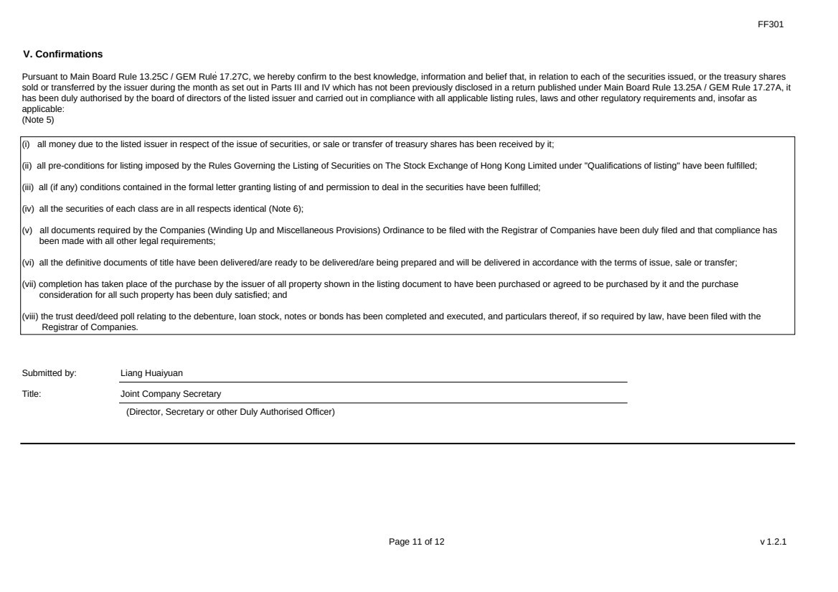 | FF301 Page 11 of 12 v 1.2.1 V. Confirmations Pursuant to Main Board Rule 13.25C / GEM Rule 17.27C, we hereby confirm to the best knowledge, information and belief that, in relation to each of the securities issued, or the treasury shares sold or transferred by the issuer during the month as set out in Parts III and IV which has not been previously disclosed in a return published under Main Board Rule 13.25A / GEM Rule 17.27A, it has been duly authorised by the board of directors of the listed issuer and carried out in compliance with all applicable listing rules, laws and other regulatory requirements and, insofar as applicable: (Note 5) (i) all money due to the listed issuer in respect of the issue of securities, or sale or transfer of treasury shares has been received by it; (ii) all pre-conditions for listing imposed by the Rules Governing the Listing of Securities on The Stock Exchange of Hong Kong Limited under "Qualifications of listing" have been fulfilled; (iii) all (if any) conditions contained in the formal letter granting listing of and permission to deal in the securities have been fulfilled; (iv) all the securities of each class are in all respects identical (Note 6); (v) all documents required by the Companies (Winding Up and Miscellaneous Provisions) Ordinance to be filed with the Registrar of Companies have been duly filed and that compliance has been made with all other legal requirements; (vi) all the definitive documents of title have been delivered/are ready to be delivered/are being prepared and will be delivered in accordance with the terms of issue, sale or transfer; (vii) completion has taken place of the purchase by the issuer of all property shown in the listing document to have been purchased or agreed to be purchased by it and the purchase consideration for all such property has been duly satisfied; and (viii) the trust deed/deed poll relating to the debenture, loan stock, notes or bonds has been completed and executed, and particulars thereof, if so required by law, have been filed with the Registrar of Companies. Submitted by: Liang Huaiyuan Title: Joint Company Secretary (Director, Secretary or other Duly Authorised Officer)
 | 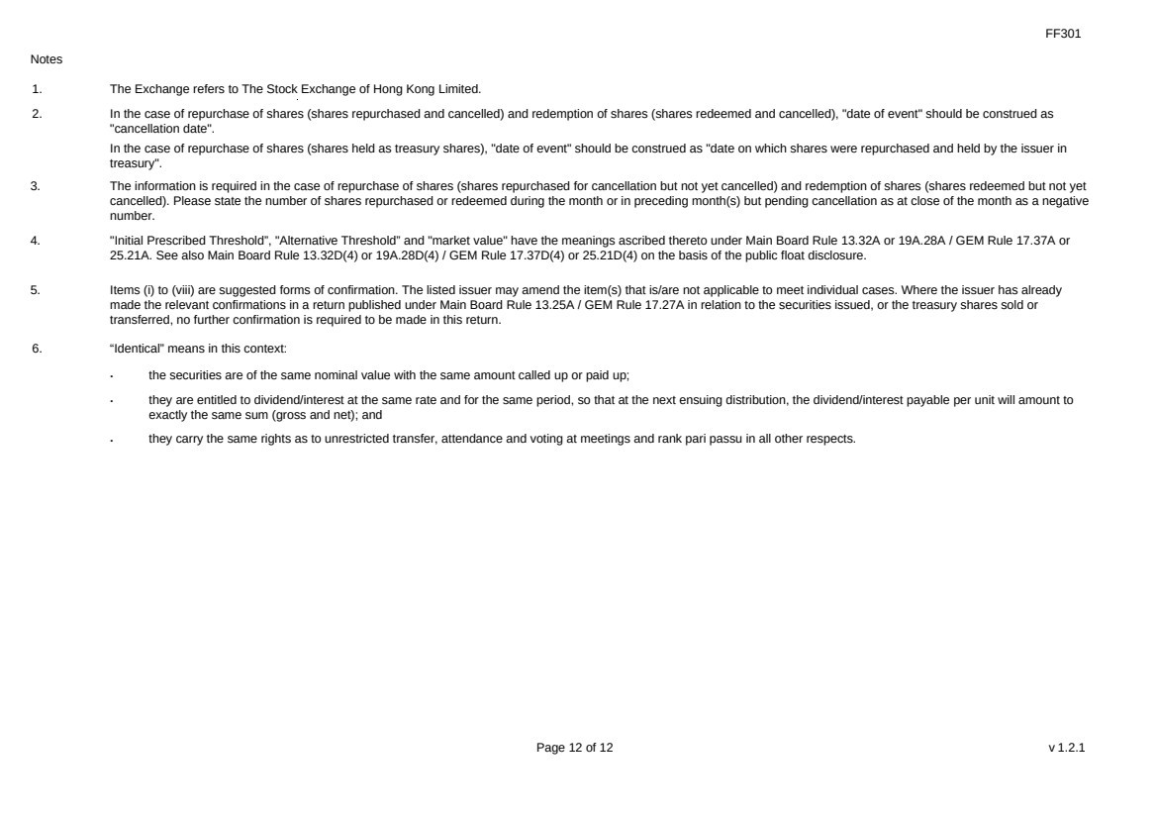 | FF301 Page 12 of 12 v 1.2.1 Notes 1. The Exchange refers to The Stock Exchange of Hong Kong Limited. 2. In the case of repurchase of shares (shares repurchased and cancelled) and redemption of shares (shares redeemed and cancelled), "date of event" should be construed as "cancellation date". In the case of repurchase of shares (shares held as treasury shares), "date of event" should be construed as "date on which shares were repurchased and held by the issuer in treasury". 3. The information is required in the case of repurchase of shares (shares repurchased for cancellation but not yet cancelled) and redemption of shares (shares redeemed but not yet cancelled). Please state the number of shares repurchased or redeemed during the month or in preceding month(s) but pending cancellation as at close of the month as a negative number. 4. "Initial Prescribed Threshold”, "Alternative Threshold” and "market value" have the meanings ascribed thereto under Main Board Rule 13.32A or 19A.28A / GEM Rule 17.37A or 25.21A. See also Main Board Rule 13.32D(4) or 19A.28D(4) / GEM Rule 17.37D(4) or 25.21D(4) on the basis of the public float disclosure. 5. Items (i) to (viii) are suggested forms of confirmation. The listed issuer may amend the item(s) that is/are not applicable to meet individual cases. Where the issuer has already made the relevant confirmations in a return published under Main Board Rule 13.25A / GEM Rule 17.27A in relation to the securities issued, or the treasury shares sold or transferred, no further confirmation is required to be made in this return. 6. “Identical” means in this context: ． the securities are of the same nominal value with the same amount called up or paid up; ． they are entitled to dividend/interest at the same rate and for the same period, so that at the next ensuing distribution, the dividend/interest payable per unit will amount to exactly the same sum (gross and net); and ． they carry the same rights as to unrestricted transfer, attendance and voting at meetings and rank pari passu in all other respects.

