UNITED STATES

SECURITIES AND EXCHANGE COMMISSION

WASHINGTON, D.C. 20549

FORM 6-K

REPORT OF FOREIGN PRIVATE ISSUER

PURSUANT TO RULE 13a-16 OR 15d-16 UNDER

THE SECURITIES EXCHANGE ACT OF 1934

For the month of June 2026

Commission File Number: 001-40460

KANZHUN LIMITED

21/F, GrandyVic Building,

Taiyanggong Middle Road

Chaoyang District, Beijing 100028

People’s Republic of China

(Address of principal executive offices)

Indicate by check mark whether the registrant files or will file annual reports under cover of Form 20-F or Form 40-F.

Form 20-F ☒ Form 40-F ☐

 |  |  |  |  |  |  |  | Exhibit Index
Exhibit No. |  |  |  |  |  |  |  |  | Description
99.1 |  |  |  | Next Day Disclosure Return, dated June 16, 2026
99.2 |  |  |  | Grant of Share Awards

SIGNATURES

Pursuant to the requirements of the Securities Exchange Act of 1934, the registrant has duly caused this report to be signed on its behalf by the undersigned, thereunto duly authorized.

KANZHUN LIMITED

By | : | /s/ Peng Zhao
Name | : | Peng Zhao
Title | : Director and Chief Executive Officer

Date: June 16, 2026

Exhibit 99.1
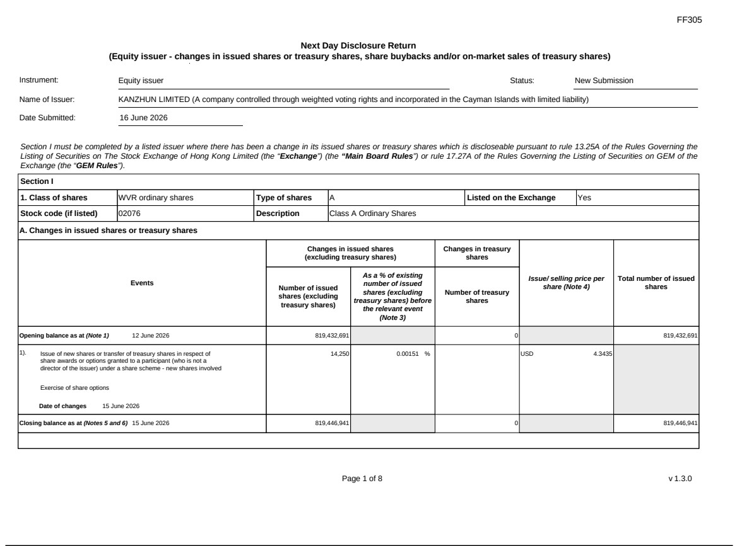

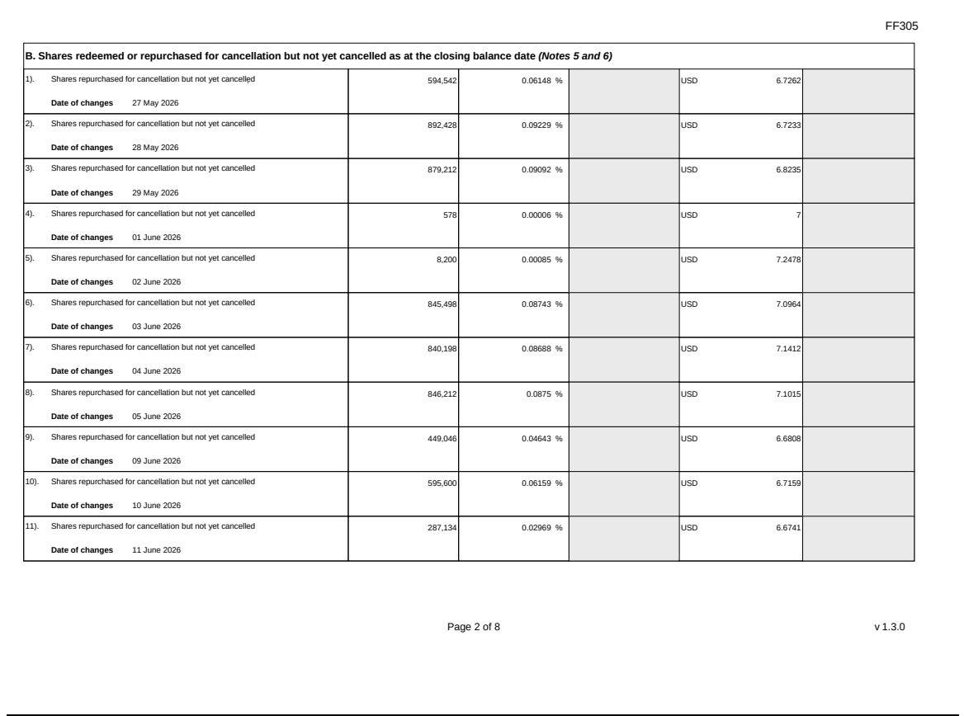

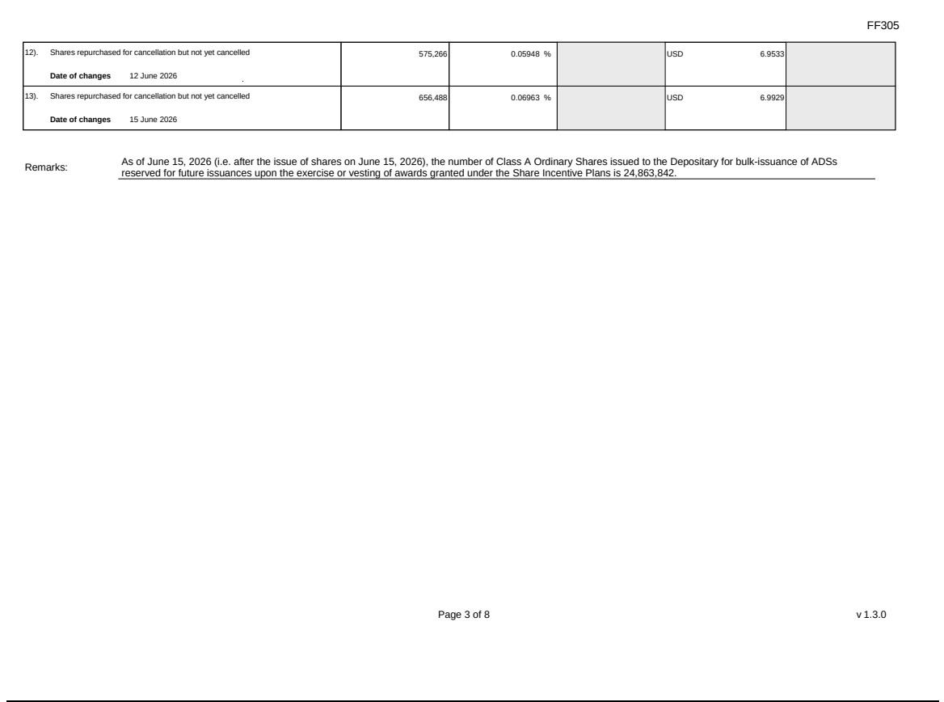

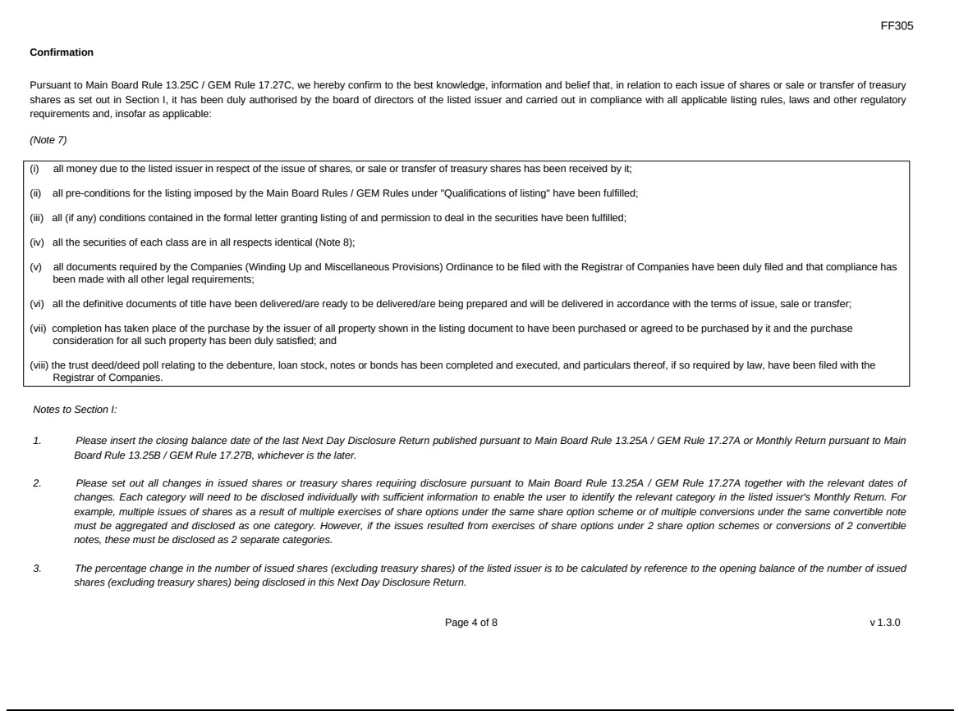

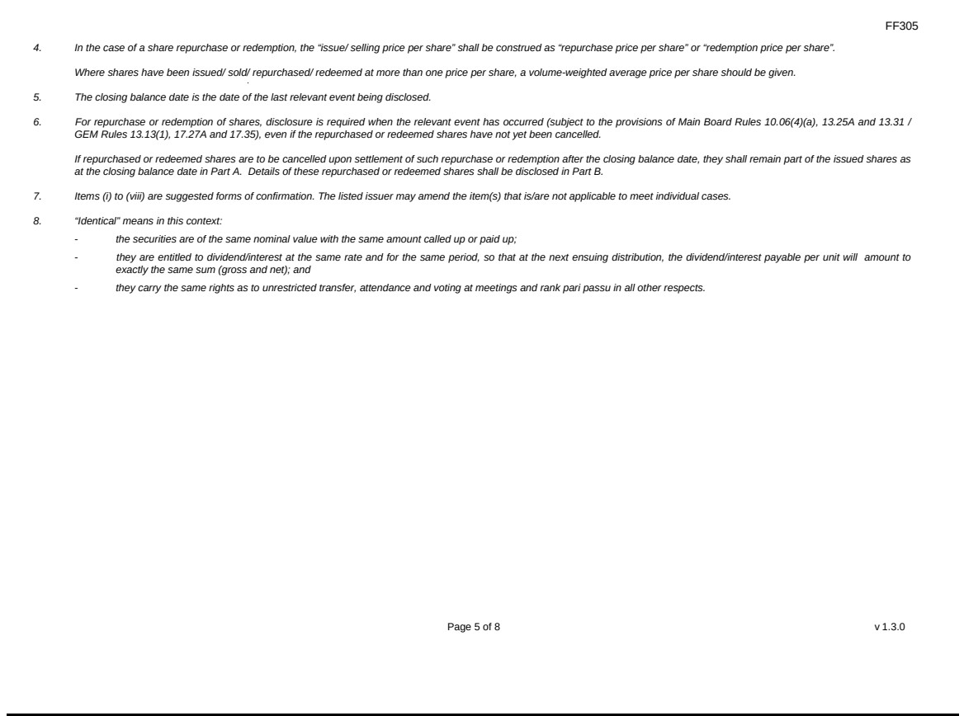

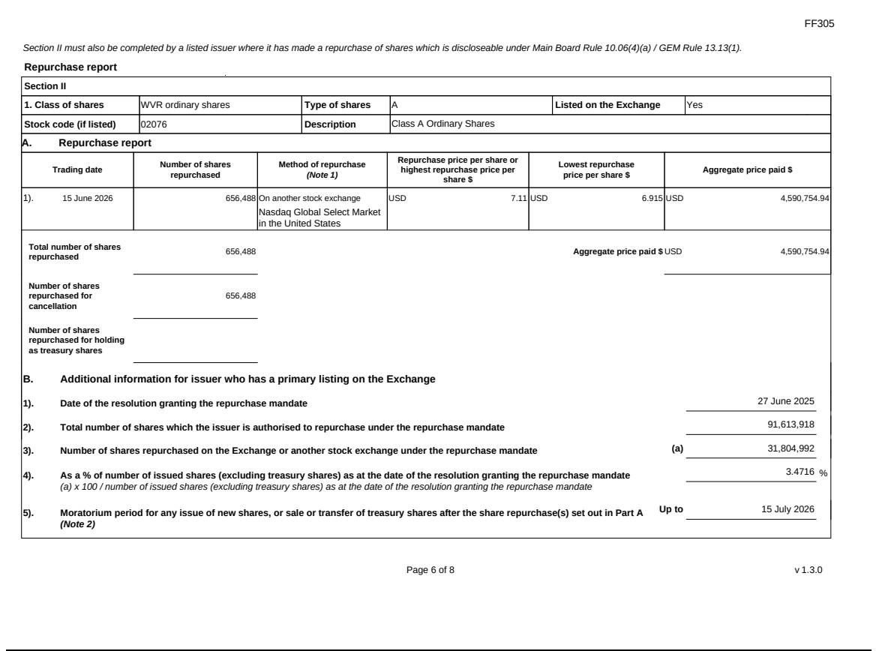

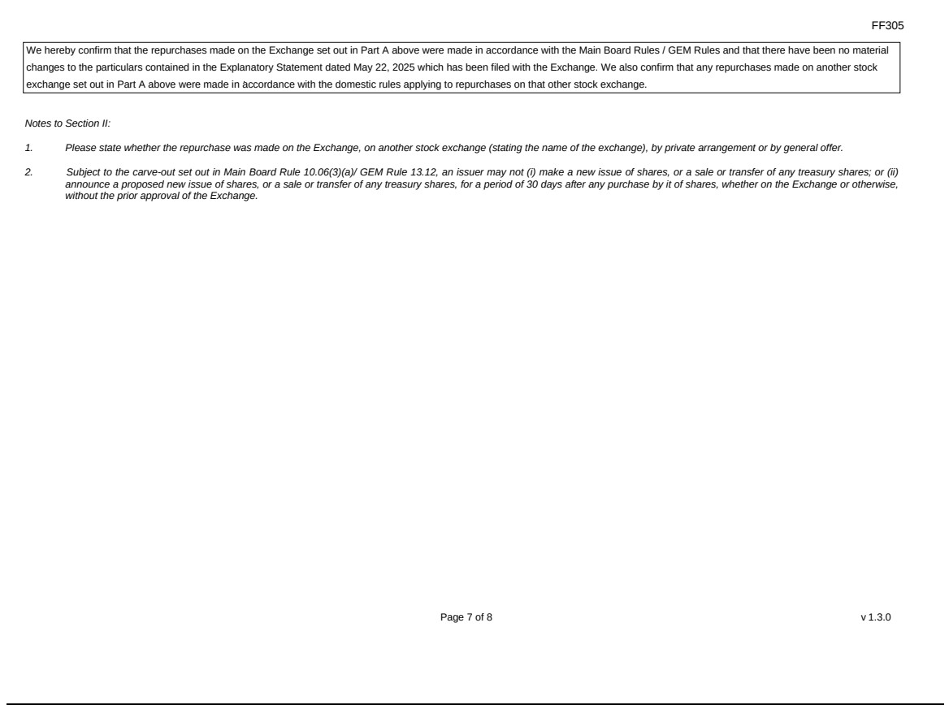

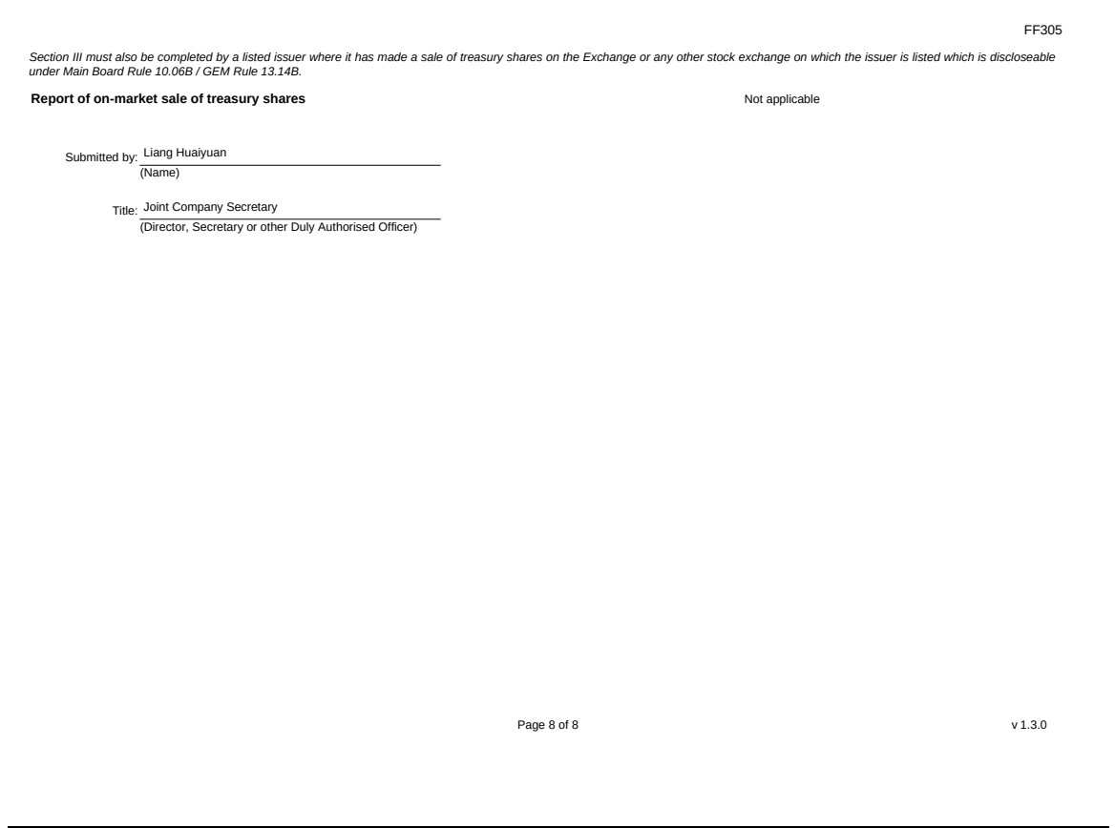

Exhibit 99.2

Hong Kong Exchanges and Clearing Limited and The Stock Exchange of Hong Kong Limited take no responsibility for the contents of this announcement, make no representation as to its accuracy or completeness and expressly disclaim any liability whatsoever for any loss howsoever arising from or in reliance upon the whole or any part of the contents of this announcement.
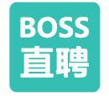

KANZHUN LIMITED

看準科技有限公司

(A company controlled through weighted voting rights and incorporated in the Cayman Islands with limited liability)

(Stock Code: 2076)

(Nasdaq Stock Ticker: BZ)

GRANT OF SHARE AWARDS

On June 15, 2026, the Company granted an aggregate of 550,498 share awards in the form of RSUs (the “Share Awards”) (representing the same number of Class A Ordinary Shares) to 45 employees pursuant to the Post-IPO Share Scheme (the “Grants”).

The Grants are subject to the terms and conditions of the Post-IPO Share Scheme and the award agreements entered into between the Company and each of the Grantees. The principal terms of the Post-IPO Share Scheme were set out in the section headed “Statutory and General Information – D. Share Incentive Plans – 2. Post-IPO Share Scheme” in Appendix IV to the listing document of the Company dated December 16, 2022.

The Share Awards will be satisfied through utilizing the Class A Ordinary Shares held by the depositary of the ADSs for bulk issuance of ADSs reserved for future issuances upon the exercise or vesting of awards granted under the Post-IPO Share Scheme.

Details of the Grants are as follows:
Date of the Grants | June 15, 2026
Number of Grantees | 45 employees
Number of Share Awards granted | 550,498 Class A Ordinary Shares
Issue price of Share Awards granted | Nil per Share Award
Closing price of the Class A Ordinary Shares on the Date of the Grants | HK$53.85 per Share
 | 1

Vesting Periods of the Share Awards

For the Grants, subject to the Grantee’s continued employment relationship with the Company on such vesting dates, (i) approximately 82.15% of the Share Awards under the Grants shall vest as follows: 50% shall vest on the second anniversary of the date of the Grants; 25% shall vest on the third anniversary of the date of the Grants; and 25% shall vest on the fourth anniversary of the date of the Grants; and (ii) approximately 17.85% of the Share Awards under the Grants shall vest in equal portions on each of the first, second, third and fourth anniversary of the date of the Grants, respectively.

Performance Target

A portion of the Share Awards representing approximately 84.87% of the Share Awards under the Grants shall be vested subject to a performance target whereby the number of Share Awards to be vested shall be directly linked to the result of the Grantee’s performance evaluation in the relevant period as assessed by the Group. The vesting of the remaining portion of the Share Awards under the Grants is not subject to any performance target.

Clawback Mechanism

The Share Awards are subject to clawback in the event that:

- the Grantee ceases to be a selected participant by reason of the termination of employment or contractual engagement with the Group or Related Entity for cause or without notice or with payment in lieu of notice;

- the Grantee has been convicted of a criminal offence involving his/her integrity or honesty; or

- in the reasonable opinion of the scheme administrator, the Grantee has engaged in serious misconduct or breaches the terms of the Post-IPO Share Scheme in any material respect.

Listing Rules Implications

The Grantees under the Employee Grants are employees of the Group and do not fall under any of the following categories: (a) a Director, chief executive, or substantial Shareholder of the Company, or an associate of any of them; (b) a participant with share options and awards granted and to be granted in the 12-month period up to and including the date of such grant in aggregate to exceed 1% individual limit for the purpose of Rule 17.03D of the Listing Rules; or (c) a related entity participant or service provider with options and awards granted and to be granted in any 12-month period exceeding 0.1% of the relevant class of Shares in issue (excluding treasury shares).

Reasons for and benefits of the Grants

The reasons for the grants of Share Awards are to reward continued efforts for the success of the Company and provide incentives for the Grantees to exert maximum efforts, and to provide a means by which more employees may be given an opportunity to benefit from increases in value of the Shares through the granting of the Share Awards. Such Grants will encourage them to work towards enhancing the value of the Company and the Shares for the benefits of the Company and the Shareholders as a whole.

2

Class A Ordinary Shares available for future grant under the Post-IPO Share Scheme

As at the date of this announcement and following the Grants, the number of Class A Ordinary Shares available for future grant under the scheme mandate limit of the Post-IPO Share Scheme is 48,394,810.

Definitions

In this announcement, unless the context otherwise requires, the following expressions shall have the following meanings:

“ADSs” | American Depositary Shares, each representing two Class A Ordinary Shares
“Articles of Association” | the fifteenth amended and restated articles of association of the Company conditionally adopted by special resolutions of the Shareholders on December 14, 2022,
 | which took effect upon the listing of the Company’s Class A Ordinary Share on the Main Board of The Stock Exchange of Hong Kong Limited
“Board” | the board of Directors of the Company
“Class A Ordinary Share(s)” | class A ordinary shares in the share capital of the Company with a par value of US$0.0001 each, conferring a holder of Class A Ordinary Share one vote per Share on
 | any resolution tabled at the Company’s general meeting
“Class B Ordinary Share(s)” | class B ordinary shares in the share capital of the Company with a par value of US$0.0001 each, conferring weighted voting rights in the Company such that a holder of
 | a Class B Ordinary Share is entitled to ten votes per Share on any resolution tabled at the Company’s general meeting, save for resolutions with respect to any Reserved
 | Matters, in which case they shall be entitled to one vote per Share
“Company” | KANZHUN LIMITED (看準科技有限公司), a company with limited liability incorporated in the Cayman Islands on January 16, 2014
“Director(s)” | the director(s) of the Company
“Grantee(s)” | the employee(s) of the Group who were granted Share Awards in accordance with the Post-IPO Share Scheme on the date of the Grants
“Group” | the Company, its subsidiaries and its consolidated affiliated entities
“Holding Company” | a company of which the Company is a subsidiary
“HK$” | Hong Kong dollars, the lawful currency of Hong Kong
 | 3

“Listing Rules”

the Rules Governing the Listing of Securities on The Stock Exchange of Hong Kong Limited, as amended, supplemented or otherwise modified from time to time

“Post-IPO Share Scheme”

the share incentive plan conditionally approved and adopted on December 14, 2022, which took effect upon the listing of the Company’s Class A Ordinary Share on the Main Board of The Stock Exchange of Hong Kong Limited

“Related Entity”

(i) a Holding Company; (ii) subsidiaries of the Holding Company other than members of the Group; or (iii) any company which is an associate of the Company

“Reserved Matters”

those matters resolutions with respect to which each Share is entitled to one vote at general meetings of the Company pursuant to the Articles of Association, being (i) any amendment to the Memorandum or Articles, including the variation of the rights attached to any class of shares, (ii) the appointment, election or removal of any independent non-executive Director, (iii) the appointment or removal of the Company’s auditors, and (iv) the voluntary liquidation or winding-up of the Company

“RSU(s)”

restricted share units

“Share(s)”

the Class A Ordinary Shares and the Class B Ordinary Shares in the share capital of the Company, as the context so requires

“Share Award(s)”

an award which vests in the form of the right either to (i) subscribe for and/or be issued or (ii) purchase such number of Class A Ordinary Shares as the scheme administrator may determine at the issue price, pursuant to the terms of the Post-IPO Share Scheme

“Shareholder(s)”

the shareholders of the Company

“US$”

U.S. dollars, the lawful currency of the United States of America

By order of the Board

KANZHUN LIMITED

Mr. Peng Zhao

Founder, Chairman and Chief Executive Officer

Hong Kong, June 15, 2026

As at the date of this announcement, the Board of the Company comprises Mr. Peng Zhao, Mr. Xu Chen, Mr. Tao Zhang, Ms. Xiehua Wang and Ms. Yang Mu as the executive Directors, Mr. Haiyang Yu as the non-executive Director, Mr. Yonggang Sun, Mr. Yan Li and Ms. Hongyu Liu as the independent non-executive Directors.

4

