UNITED STATES
SECURITIES AND EXCHANGE COMMISSION
WASHINGTON, D.C. 20549

FORM 6-K

REPORT OF FOREIGN PRIVATE ISSUER
PURSUANT TO RULE 13a-16 OR 15d-16 UNDER
THE SECURITIES EXCHANGE ACT OF 1934

For the month of June 2026

Commission File Number: 001-40460

KANZHUN LIMITED

21/F, GrandyVic Building,
Taiyanggong Middle Road
Chaoyang District, Beijing 100028
People’s Republic of China
(Address of principal executive offices)

Indicate by check mark whether the registrant files or will file annual reports under cover of Form 20-F or Form 40-F.

Form 20-F ☒ Form 40-F ☐

Exhibit Index

Exhibit No. | Description
99.1 | Next Day Disclosure Return, dated June 8, 2026

SIGNATURES

Pursuant to the requirements of the Securities Exchange Act of 1934, the registrant has duly caused this report to be signed on its behalf by the undersigned, thereunto duly authorized.

 | KANZHUN LIMITED
 | By : | /s/ Peng Zhao
 | Name: | Peng Zhao
 | Title: | Director and Chief Executive Officer

Date: June 8, 2026

Exhibit 99.1
 | 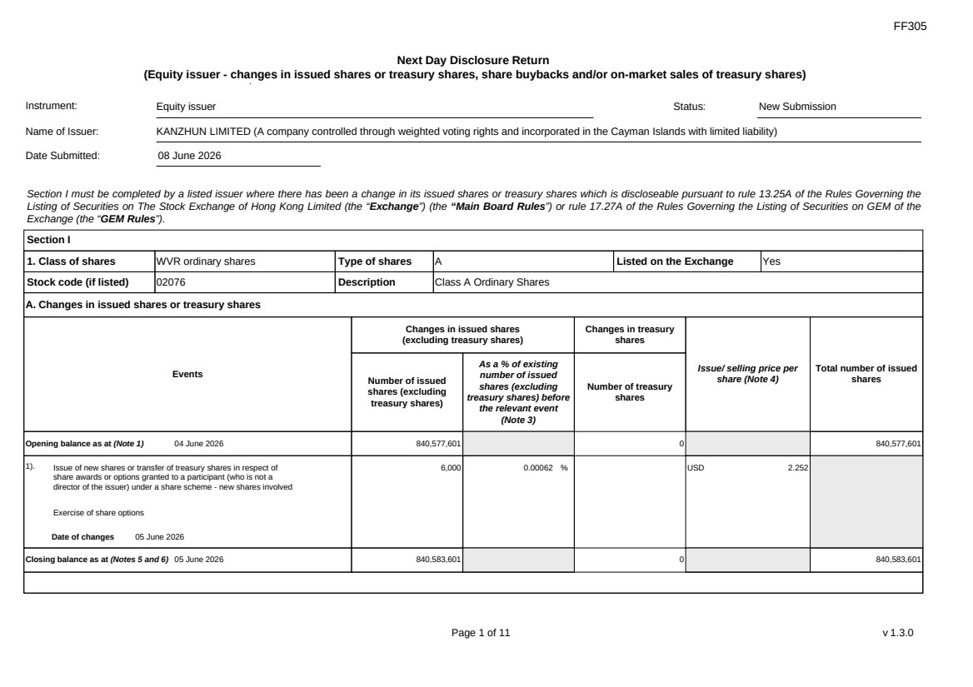 | FF305 Page 1 of 11 v 1.3.0 Next Day Disclosure Return (Equity issuer - changes in issued shares or treasury shares, share buybacks and/or on-market sales of treasury shares) Instrument: Equity issuer Status: New Submission Name of Issuer: KANZHUN LIMITED (A company controlled through weighted voting rights and incorporated in the Cayman Islands with limited liability) Date Submitted: 08 June 2026 Section I must be completed by a listed issuer where there has been a change in its issued shares or treasury shares which is discloseable pursuant to rule 13.25A of the Rules Governing the Listing of Securities on The Stock Exchange of Hong Kong Limited (the “Exchange”) (the “Main Board Rules”) or rule 17.27A of the Rules Governing the Listing of Securities on GEM of the Exchange (the “GEM Rules”). Section I 1. Class of shares WVR ordinary shares Type of shares A Listed on the Exchange Yes Stock code (if listed) 02076 Description Class A Ordinary Shares A. Changes in issued shares or treasury shares Events Changes in issued shares (excluding treasury shares) Number of issued shares (excluding treasury shares) As a % of existing number of issued shares (excluding treasury shares) before the relevant event (Note 3) Changes in treasury shares Number of treasury shares Issue/ selling price per share (Note 4) Total number of issued shares Opening balance as at (Note 1) 04 June 2026 840,577,601 0 840,577,601 1). Issue of new shares or transfer of treasury shares in respect of share awards or options granted to a participant (who is not a director of the issuer) under a share scheme - new shares involved Exercise of share options Date of changes 05 June 2026 6,000 0.00062 % USD 2.252 Closing balance as at (Notes 5 and 6) 05 June 2026 840,583,601 0 840,583,601
 | 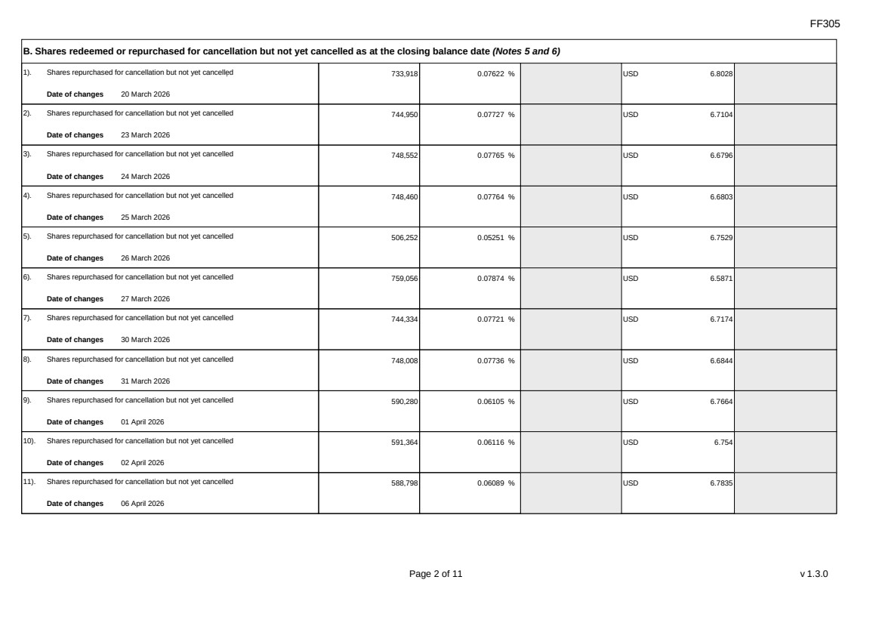 | FF305 Page 2 of 11 v 1.3.0 B. Shares redeemed or repurchased for cancellation but not yet cancelled as at the closing balance date (Notes 5 and 6) 1). Shares repurchased for cancellation but not yet cancelled Date of changes 20 March 2026 733,918 0.07622 % USD 6.8028 2). Shares repurchased for cancellation but not yet cancelled Date of changes 23 March 2026 744,950 0.07727 % USD 6.7104 3). Shares repurchased for cancellation but not yet cancelled Date of changes 24 March 2026 748,552 0.07765 % USD 6.6796 4). Shares repurchased for cancellation but not yet cancelled Date of changes 25 March 2026 748,460 0.07764 % USD 6.6803 5). Shares repurchased for cancellation but not yet cancelled Date of changes 26 March 2026 506,252 0.05251 % USD 6.7529 6). Shares repurchased for cancellation but not yet cancelled Date of changes 27 March 2026 759,056 0.07874 % USD 6.5871 7). Shares repurchased for cancellation but not yet cancelled Date of changes 30 March 2026 744,334 0.07721 % USD 6.7174 8). Shares repurchased for cancellation but not yet cancelled Date of changes 31 March 2026 748,008 0.07736 % USD 6.6844 9). Shares repurchased for cancellation but not yet cancelled Date of changes 01 April 2026 590,280 0.06105 % USD 6.7664 10). Shares repurchased for cancellation but not yet cancelled Date of changes 02 April 2026 591,364 0.06116 % USD 6.754 11). Shares repurchased for cancellation but not yet cancelled Date of changes 06 April 2026 588,798 0.06089 % USD 6.7835
 | 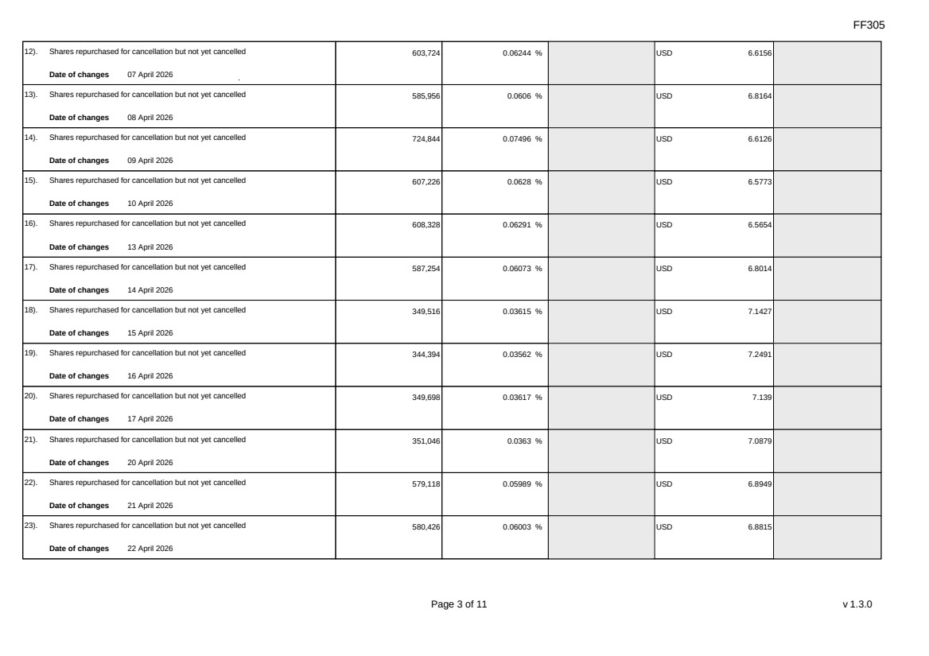 | FF305 Page 3 of 11 v 1.3.0 12). Shares repurchased for cancellation but not yet cancelled Date of changes 07 April 2026 603,724 0.06244 % USD 6.6156 13). Shares repurchased for cancellation but not yet cancelled Date of changes 08 April 2026 585,956 0.0606 % USD 6.8164 14). Shares repurchased for cancellation but not yet cancelled Date of changes 09 April 2026 724,844 0.07496 % USD 6.6126 15). Shares repurchased for cancellation but not yet cancelled Date of changes 10 April 2026 607,226 0.0628 % USD 6.5773 16). Shares repurchased for cancellation but not yet cancelled Date of changes 13 April 2026 608,328 0.06291 % USD 6.5654 17). Shares repurchased for cancellation but not yet cancelled Date of changes 14 April 2026 587,254 0.06073 % USD 6.8014 18). Shares repurchased for cancellation but not yet cancelled Date of changes 15 April 2026 349,516 0.03615 % USD 7.1427 19). Shares repurchased for cancellation but not yet cancelled Date of changes 16 April 2026 344,394 0.03562 % USD 7.2491 20). Shares repurchased for cancellation but not yet cancelled Date of changes 17 April 2026 349,698 0.03617 % USD 7.139 21). Shares repurchased for cancellation but not yet cancelled Date of changes 20 April 2026 351,046 0.0363 % USD 7.0879 22). Shares repurchased for cancellation but not yet cancelled Date of changes 21 April 2026 579,118 0.05989 % USD 6.8949 23). Shares repurchased for cancellation but not yet cancelled Date of changes 22 April 2026 580,426 0.06003 % USD 6.8815
 | 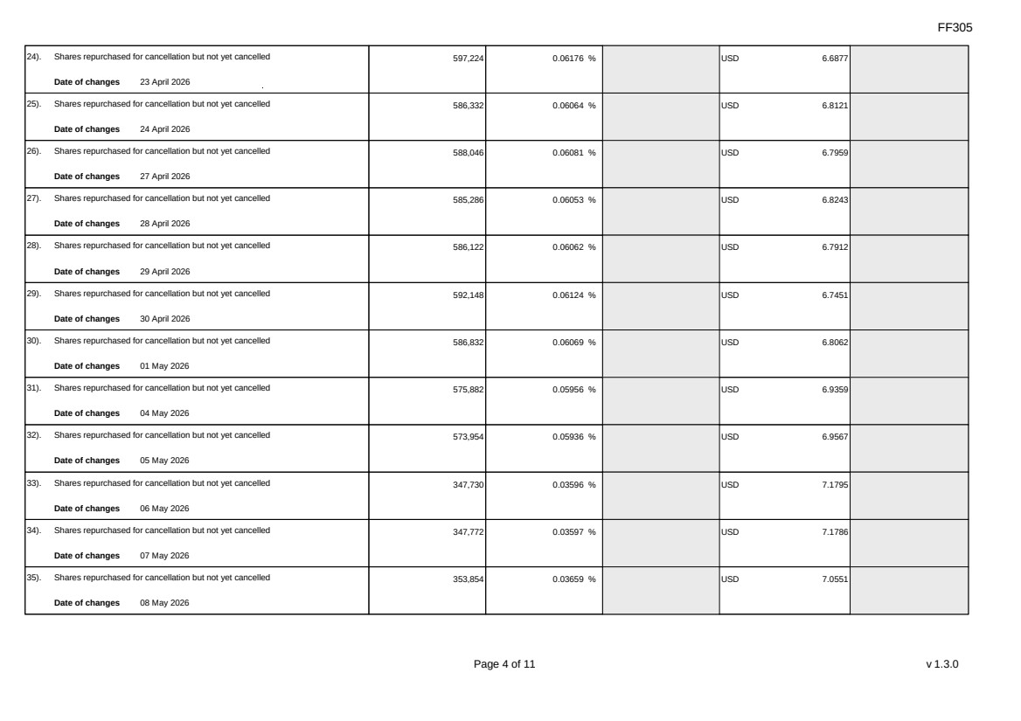 | FF305 Page 4 of 11 v 1.3.0 24). Shares repurchased for cancellation but not yet cancelled Date of changes 23 April 2026 597,224 0.06176 % USD 6.6877 25). Shares repurchased for cancellation but not yet cancelled Date of changes 24 April 2026 586,332 0.06064 % USD 6.8121 26). Shares repurchased for cancellation but not yet cancelled Date of changes 27 April 2026 588,046 0.06081 % USD 6.7959 27). Shares repurchased for cancellation but not yet cancelled Date of changes 28 April 2026 585,286 0.06053 % USD 6.8243 28). Shares repurchased for cancellation but not yet cancelled Date of changes 29 April 2026 586,122 0.06062 % USD 6.7912 29). Shares repurchased for cancellation but not yet cancelled Date of changes 30 April 2026 592,148 0.06124 % USD 6.7451 30). Shares repurchased for cancellation but not yet cancelled Date of changes 01 May 2026 586,832 0.06069 % USD 6.8062 31). Shares repurchased for cancellation but not yet cancelled Date of changes 04 May 2026 575,882 0.05956 % USD 6.9359 32). Shares repurchased for cancellation but not yet cancelled Date of changes 05 May 2026 573,954 0.05936 % USD 6.9567 33). Shares repurchased for cancellation but not yet cancelled Date of changes 06 May 2026 347,730 0.03596 % USD 7.1795 34). Shares repurchased for cancellation but not yet cancelled Date of changes 07 May 2026 347,772 0.03597 % USD 7.1786 35). Shares repurchased for cancellation but not yet cancelled Date of changes 08 May 2026 353,854 0.03659 % USD 7.0551
 | 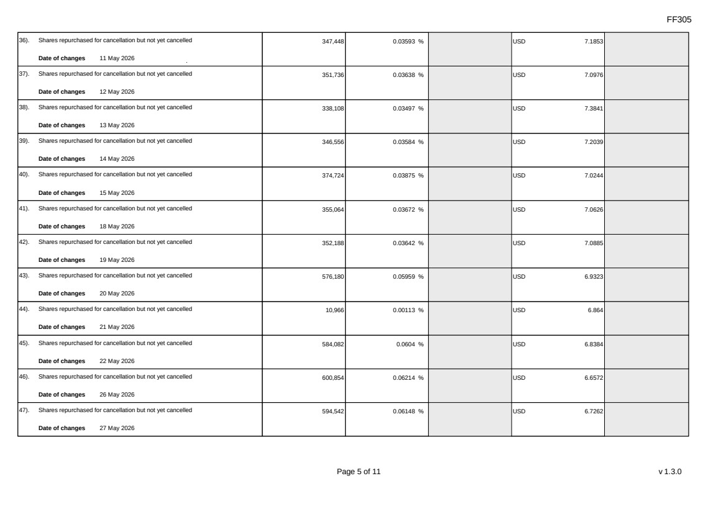 | FF305 Page 5 of 11 v 1.3.0 36). Shares repurchased for cancellation but not yet cancelled Date of changes 11 May 2026 347,448 0.03593 % USD 7.1853 37). Shares repurchased for cancellation but not yet cancelled Date of changes 12 May 2026 351,736 0.03638 % USD 7.0976 38). Shares repurchased for cancellation but not yet cancelled Date of changes 13 May 2026 338,108 0.03497 % USD 7.3841 39). Shares repurchased for cancellation but not yet cancelled Date of changes 14 May 2026 346,556 0.03584 % USD 7.2039 40). Shares repurchased for cancellation but not yet cancelled Date of changes 15 May 2026 374,724 0.03875 % USD 7.0244 41). Shares repurchased for cancellation but not yet cancelled Date of changes 18 May 2026 355,064 0.03672 % USD 7.0626 42). Shares repurchased for cancellation but not yet cancelled Date of changes 19 May 2026 352,188 0.03642 % USD 7.0885 43). Shares repurchased for cancellation but not yet cancelled Date of changes 20 May 2026 576,180 0.05959 % USD 6.9323 44). Shares repurchased for cancellation but not yet cancelled Date of changes 21 May 2026 10,966 0.00113 % USD 6.864 45). Shares repurchased for cancellation but not yet cancelled Date of changes 22 May 2026 584,082 0.0604 % USD 6.8384 46). Shares repurchased for cancellation but not yet cancelled Date of changes 26 May 2026 600,854 0.06214 % USD 6.6572 47). Shares repurchased for cancellation but not yet cancelled Date of changes 27 May 2026 594,542 0.06148 % USD 6.7262
 | 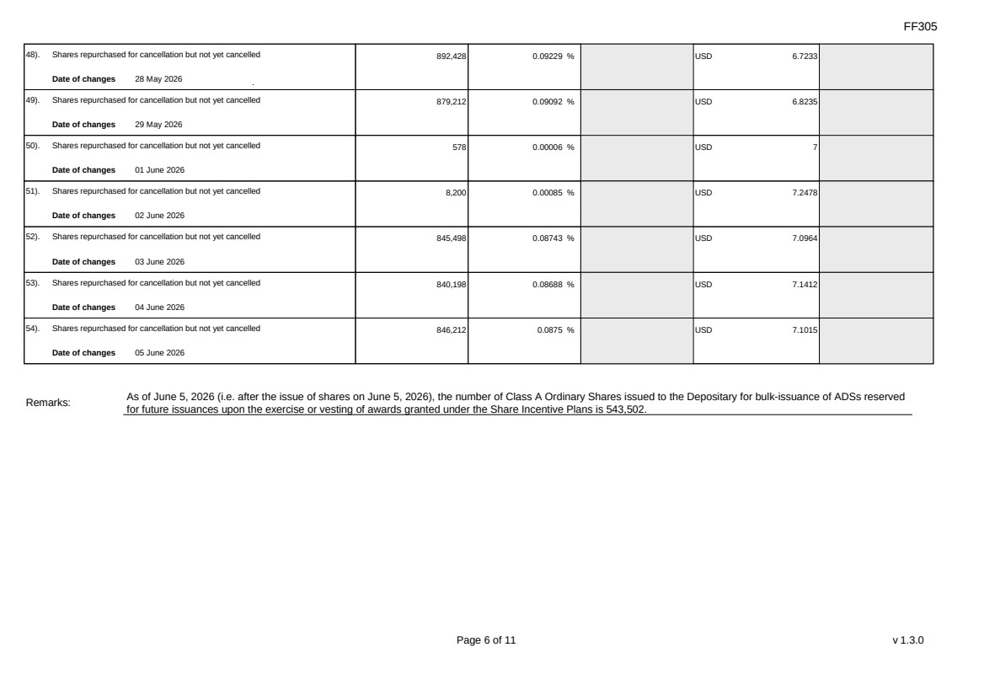 | FF305 Page 6 of 11 v 1.3.0 48). Shares repurchased for cancellation but not yet cancelled Date of changes 28 May 2026 892,428 0.09229 % USD 6.7233 49). Shares repurchased for cancellation but not yet cancelled Date of changes 29 May 2026 879,212 0.09092 % USD 6.8235 50). Shares repurchased for cancellation but not yet cancelled Date of changes 01 June 2026 578 0.00006 % USD 7 51). Shares repurchased for cancellation but not yet cancelled Date of changes 02 June 2026 8,200 0.00085 % USD 7.2478 52). Shares repurchased for cancellation but not yet cancelled Date of changes 03 June 2026 845,498 0.08743 % USD 7.0964 53). Shares repurchased for cancellation but not yet cancelled Date of changes 04 June 2026 840,198 0.08688 % USD 7.1412 54). Shares repurchased for cancellation but not yet cancelled Date of changes 05 June 2026 846,212 0.0875 % USD 7.1015 Remarks: As of June 5, 2026 (i.e. after the issue of shares on June 5, 2026), the number of Class A Ordinary Shares issued to the Depositary for bulk-issuance of ADSs reserved for future issuances upon the exercise or vesting of awards granted under the Share Incentive Plans is 543,502.
 | 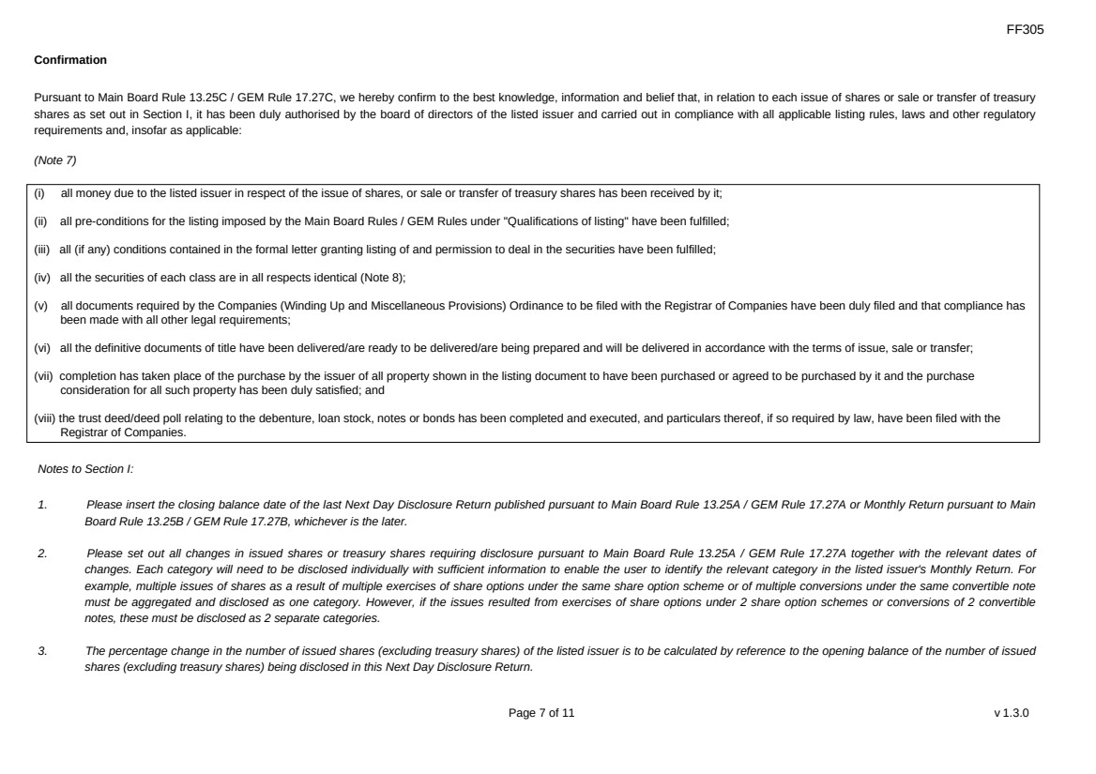 | FF305 Page 7 of 11 v 1.3.0 Confirmation Pursuant to Main Board Rule 13.25C / GEM Rule 17.27C, we hereby confirm to the best knowledge, information and belief that, in relation to each issue of shares or sale or transfer of treasury shares as set out in Section I, it has been duly authorised by the board of directors of the listed issuer and carried out in compliance with all applicable listing rules, laws and other regulatory requirements and, insofar as applicable: (Note 7) (i) all money due to the listed issuer in respect of the issue of shares, or sale or transfer of treasury shares has been received by it; (ii) all pre-conditions for the listing imposed by the Main Board Rules / GEM Rules under "Qualifications of listing" have been fulfilled; (iii) all (if any) conditions contained in the formal letter granting listing of and permission to deal in the securities have been fulfilled; (iv) all the securities of each class are in all respects identical (Note 8); (v) all documents required by the Companies (Winding Up and Miscellaneous Provisions) Ordinance to be filed with the Registrar of Companies have been duly filed and that compliance has been made with all other legal requirements; (vi) all the definitive documents of title have been delivered/are ready to be delivered/are being prepared and will be delivered in accordance with the terms of issue, sale or transfer; (vii) completion has taken place of the purchase by the issuer of all property shown in the listing document to have been purchased or agreed to be purchased by it and the purchase consideration for all such property has been duly satisfied; and (viii) the trust deed/deed poll relating to the debenture, loan stock, notes or bonds has been completed and executed, and particulars thereof, if so required by law, have been filed with the Registrar of Companies. Notes to Section I: 1. Please insert the closing balance date of the last Next Day Disclosure Return published pursuant to Main Board Rule 13.25A / GEM Rule 17.27A or Monthly Return pursuant to Main Board Rule 13.25B / GEM Rule 17.27B, whichever is the later. 2. Please set out all changes in issued shares or treasury shares requiring disclosure pursuant to Main Board Rule 13.25A / GEM Rule 17.27A together with the relevant dates of changes. Each category will need to be disclosed individually with sufficient information to enable the user to identify the relevant category in the listed issuer's Monthly Return. For example, multiple issues of shares as a result of multiple exercises of share options under the same share option scheme or of multiple conversions under the same convertible note must be aggregated and disclosed as one category. However, if the issues resulted from exercises of share options under 2 share option schemes or conversions of 2 convertible notes, these must be disclosed as 2 separate categories. 3. The percentage change in the number of issued shares (excluding treasury shares) of the listed issuer is to be calculated by reference to the opening balance of the number of issued shares (excluding treasury shares) being disclosed in this Next Day Disclosure Return.
 | 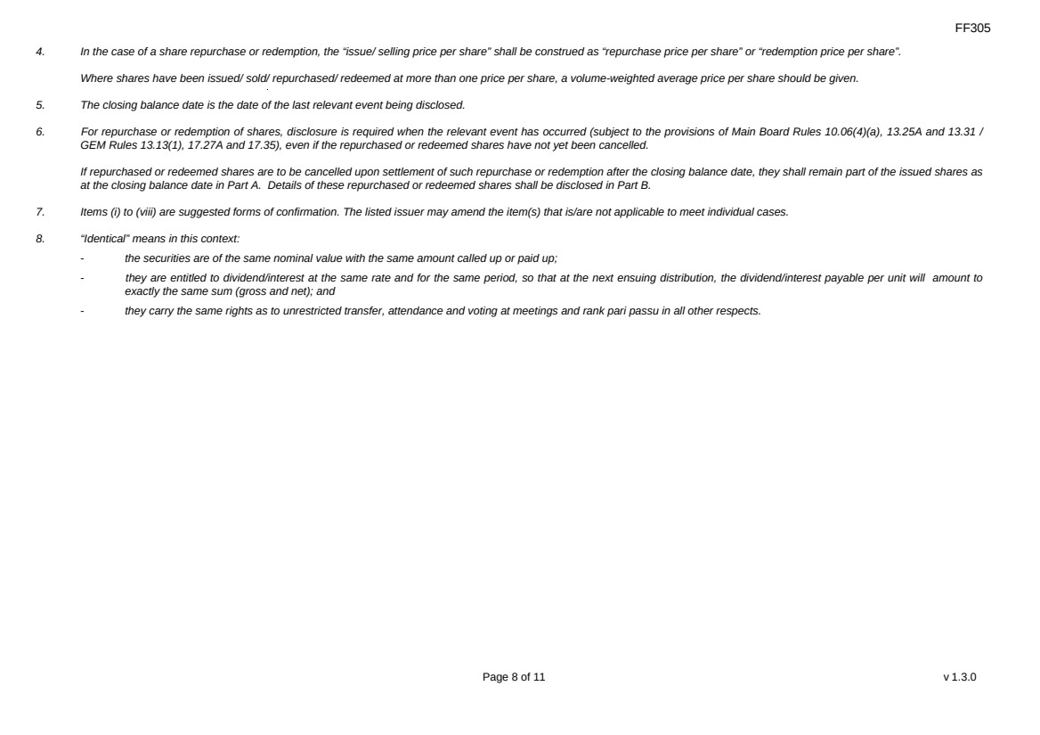 | FF305 Page 8 of 11 v 1.3.0 4. In the case of a share repurchase or redemption, the “issue/ selling price per share” shall be construed as “repurchase price per share” or “redemption price per share”. Where shares have been issued/ sold/ repurchased/ redeemed at more than one price per share, a volume-weighted average price per share should be given. 5. The closing balance date is the date of the last relevant event being disclosed. 6. For repurchase or redemption of shares, disclosure is required when the relevant event has occurred (subject to the provisions of Main Board Rules 10.06(4)(a), 13.25A and 13.31 / GEM Rules 13.13(1), 17.27A and 17.35), even if the repurchased or redeemed shares have not yet been cancelled. If repurchased or redeemed shares are to be cancelled upon settlement of such repurchase or redemption after the closing balance date, they shall remain part of the issued shares as at the closing balance date in Part A. Details of these repurchased or redeemed shares shall be disclosed in Part B. 7. Items (i) to (viii) are suggested forms of confirmation. The listed issuer may amend the item(s) that is/are not applicable to meet individual cases. 8. “Identical” means in this context: - the securities are of the same nominal value with the same amount called up or paid up; - they are entitled to dividend/interest at the same rate and for the same period, so that at the next ensuing distribution, the dividend/interest payable per unit will amount to exactly the same sum (gross and net); and - they carry the same rights as to unrestricted transfer, attendance and voting at meetings and rank pari passu in all other respects.
 | 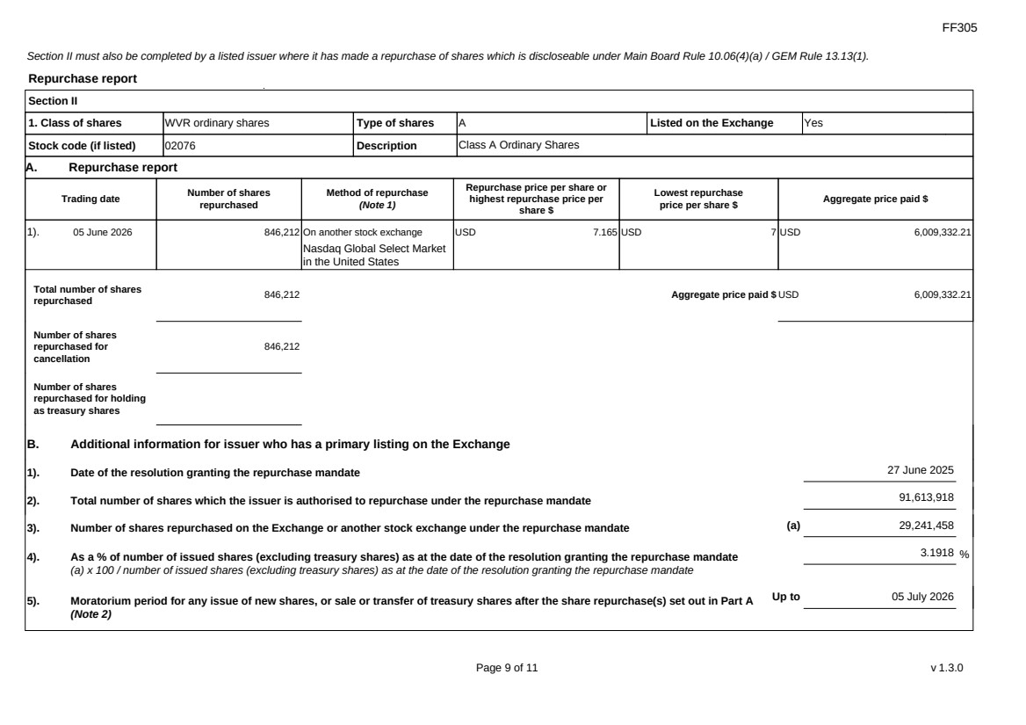 | FF305 Page 9 of 11 v 1.3.0 Section II must also be completed by a listed issuer where it has made a repurchase of shares which is discloseable under Main Board Rule 10.06(4)(a) / GEM Rule 13.13(1). Repurchase report Section II 1. Class of shares WVR ordinary shares Type of shares A Listed on the Exchange Yes Stock code (if listed) 02076 Description Class A Ordinary Shares A. Repurchase report Trading date Number of shares repurchased Method of repurchase (Note 1) Repurchase price per share or highest repurchase price per share $ Lowest repurchase price per share $ Aggregate price paid $ 1). 05 June 2026 846,212 On another stock exchange Nasdaq Global Select Market in the United States USD 7.165 USD 7 USD 6,009,332.21 Total number of shares repurchased 846,212 Aggregate price paid $ USD 6,009,332.21 Number of shares repurchased for cancellation 846,212 Number of shares repurchased for holding as treasury shares B. Additional information for issuer who has a primary listing on the Exchange 1). Date of the resolution granting the repurchase mandate 27 June 2025 2). Total number of shares which the issuer is authorised to repurchase under the repurchase mandate 91,613,918 3). Number of shares repurchased on the Exchange or another stock exchange under the repurchase mandate (a) 29,241,458 4). As a % of number of issued shares (excluding treasury shares) as at the date of the resolution granting the repurchase mandate (a) x 100 / number of issued shares (excluding treasury shares) as at the date of the resolution granting the repurchase mandate 3.1918 % 5). Moratorium period for any issue of new shares, or sale or transfer of treasury shares after the share repurchase(s) set out in Part A (Note 2) Up to 05 July 2026
 | 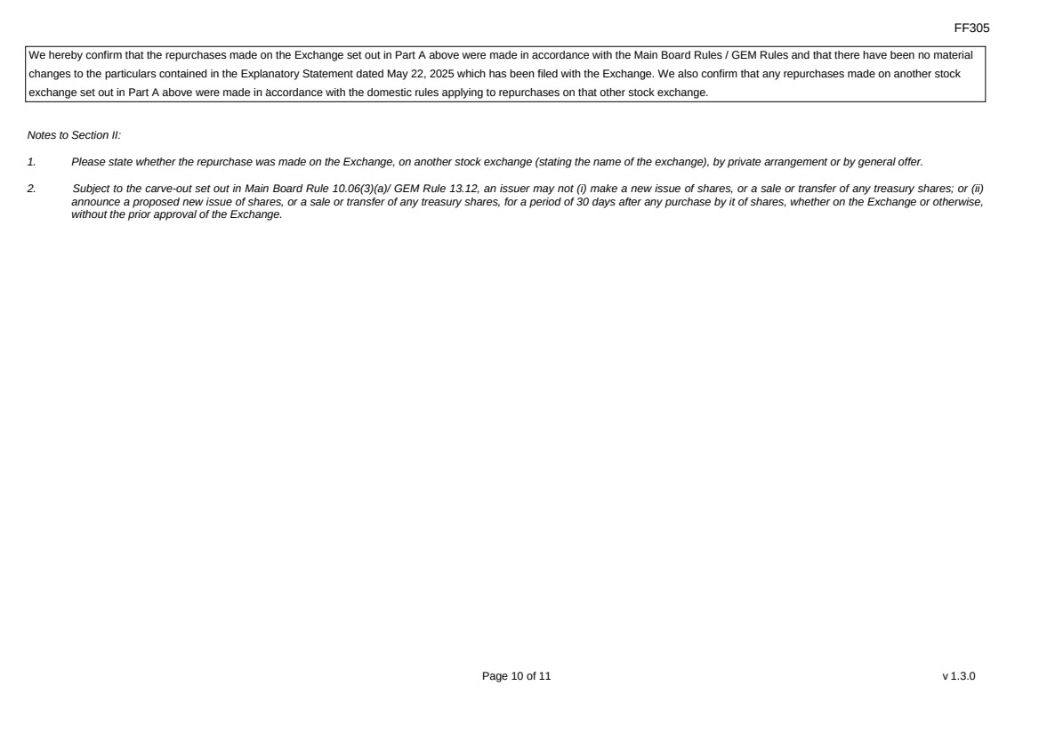 | FF305 Page 10 of 11 v 1.3.0 We hereby confirm that the repurchases made on the Exchange set out in Part A above were made in accordance with the Main Board Rules / GEM Rules and that there have been no material changes to the particulars contained in the Explanatory Statement dated May 22, 2025 which has been filed with the Exchange. We also confirm that any repurchases made on another stock exchange set out in Part A above were made in accordance with the domestic rules applying to repurchases on that other stock exchange. Notes to Section II: 1. Please state whether the repurchase was made on the Exchange, on another stock exchange (stating the name of the exchange), by private arrangement or by general offer. 2. Subject to the carve-out set out in Main Board Rule 10.06(3)(a)/ GEM Rule 13.12, an issuer may not (i) make a new issue of shares, or a sale or transfer of any treasury shares; or (ii) announce a proposed new issue of shares, or a sale or transfer of any treasury shares, for a period of 30 days after any purchase by it of shares, whether on the Exchange or otherwise, without the prior approval of the Exchange.
 | 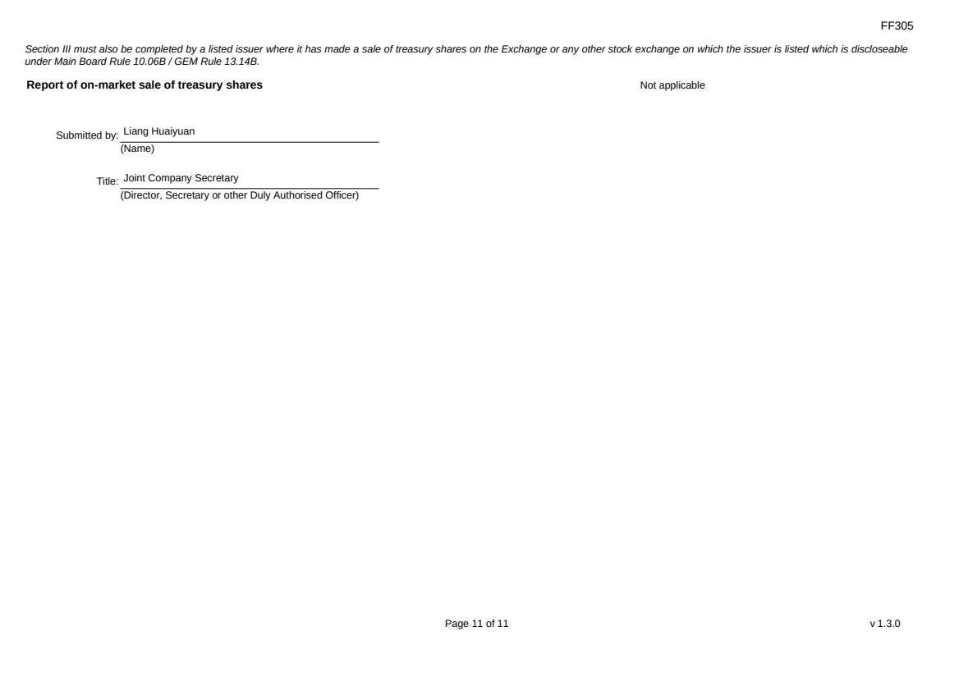 | FF305 Page 11 of 11 v 1.3.0 Section III must also be completed by a listed issuer where it has made a sale of treasury shares on the Exchange or any other stock exchange on which the issuer is listed which is discloseable under Main Board Rule 10.06B / GEM Rule 13.14B. Report of on-market sale of treasury shares Not applicable Submitted by: Liang Huaiyuan (Name) Title: Joint Company Secretary (Director, Secretary or other Duly Authorised Officer)

